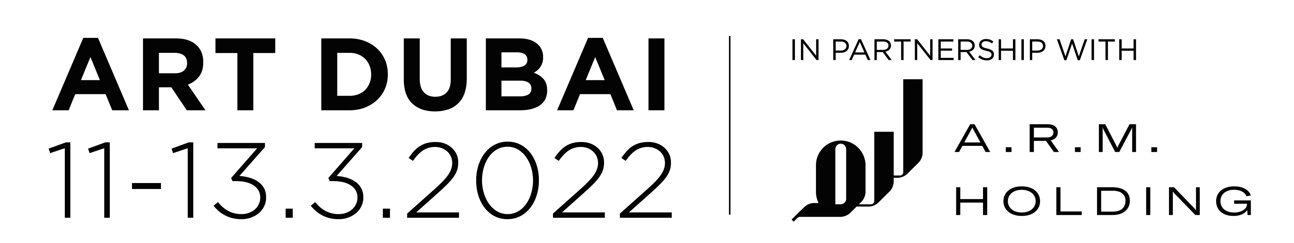

ART DUBAI 2022
TALKS AND EDUCATION PROGRAMME

For over 15 years, Art Dubai has played an important and leading role in the development of the UAE’s cultural ecosystem, and is a major contributor to the development of the country’s future cultural leaders. Art Dubai 2022 presents an expanded education and talks, including the most far-reaching children’s programme to date, developed in partnership with A.R.M. Holding, and now reaching more than 5,000 children in 80 schools across Dubai. In 2022, we are also pleased to partner with the Art Writers’ Agency, a newly created organisation which aims to support the development of UAE-based arts journalism and writers.

Art Dubai’s artistic programme is complemented by an ambitious programme of live events; a varied and multi-level talks programme that caters for a wide range of interests and expertise; and interactive family workshops, suitable for all ages. The 2022 edition of Art Dubai also features a dedicated exhibition of new NFTs by 12 UAE-based artists in the culmination of the Campus Art Dubai 9.0 Blockchain edition, one strand of Art Dubai’s extensive year-round programming aimed at providing artists with educational and professional opportunities.

First established in 2012, Campus Art Dubai was the first programme of its kind in the region and has acted as a school for artists, curators, writers, architects, designers and cultural producers based in the UAE. Each year a special curriculum is designed around a pertinent theme and CAD participants explore the significance of local knowledge with individuals and institutions in the region through course material and a series of seminars, lectures, workshops and off-site visits.
which supports the development of UAE and UAE-based artists by providing educational and professional opportunities.

Powered by Materia, Campus Art Dubai 9.0 Blockchain Edition is an 8-week programme hosting 12 artists - six UAE-based and six international - with experience in the fields of photography, videography, visual art, animation, sound or new media art. The programme culminates with participants creating their own NFT artwork which is shown in a dedicated display at Art Dubai 2022 and exhibited on Materia’s platform.

This year’s A.R.M. Holding Children’s Programme features artist-led workshops for children aged 5-17 years. With a focus on sustainability, the programme will be led by Kenyan artist Cyrus Kabiru, who will work with participants to retrieve and repurpose everyday materials from their homes and schools, and transforming them into works of art. Through these workshops, Cyrus will challenge participants to alter their perspectives, and re-examine how they see everyday objects and their wider surroundings. The first A.R.M. Holding Children’s Programme will take place at Art Dubai before expanding to take place in 80 schools - reaching more than 5000 children across Dubai, in line with A.R.M. Holding’s long-term commitment to artistic education and Dubai’s creative economy.

Art Dubai also features an innovative talks programme for a range of audiences. Entitled ‘This is the Picture’, commissioned by Shumon Basar, and taking place across four days, the 15th edition of the Global Art Forum examines the worlds of digital artefacts and crypto economies, inviting leading artists, curators, creators, thinkers and technologists to consider a range of topics from NFT art and curatorial projects, to crypto gaming and the metaverse, Web3 and Dubai’s new crypto zone. Participants for 2022 include noted collectors Guy Ullens and Ryan Zurrer, pioneering artists Holly Herndon & Mat Dryhurst and UAE blockchain advocate Saeed Al Darmaki. https://www.artdubai.ae/global-art-forum-15/

Bybit Talks is an eclectically curated series of conversations presented by the titular and leading cryptocurrency exchange, that aims to give visitors greater understanding about the rapid growth in digital platforms. Inviting guest speakers to explain more about the basics of cryptocurrency, digital media and NFT art, participants will include Tamas Banovich, co-founder of Postmasters; Seth Goldstein, co-founder of Bright Moments and Christina Chua, co-founder of SO-FAR. https://www.artdubai.ae/bybit-talks-series/

Art Writers’ Agency (AWA) was founded in 2022 by journalist and academic Melissa Gronlund to support the development of the next generation of cultural writers in a rapidly changing media landscape. The first cohort of eight writers was selected following an open call, and Art Dubai is pleased to be a founding partner of this important component of the cultural ecosystem.

Art Dubai is held under the patronage of His Highness Sheikh Mohammed bin Rashid Al Maktoum, Vice President and Prime Minister of the UAE and Ruler of Dubai. The event is held in partnership with A.R.M. Holding. The fair is sponsored by Swiss Wealth Management Group Julius Baer. The Dubai Culture & Arts Authority (Dubai Culture) is the fair’s strategic partner. Bybit is the lead partner of Art Dubai Digital.

