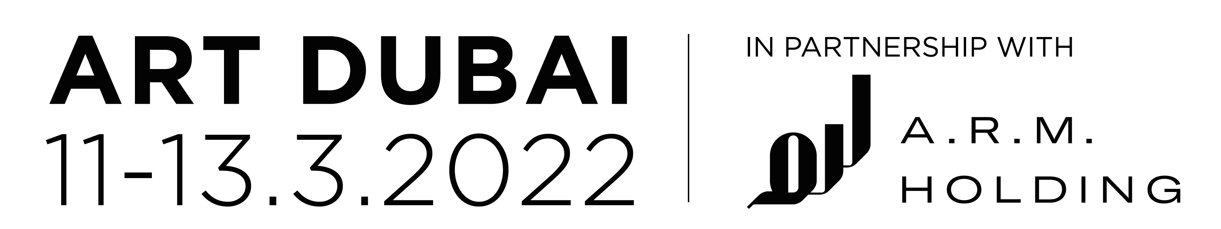

ART DUBAI 2022 COMMISSION
SAND FLOW BY INLAND X FERNANDO GARCIA-DORY

Art Dubai’s commission for 2022 is INLAND, represented by Fernando Garcia-Dory, who presents a new multi-site installation at the fair and in locations around Dubai. Sand Flow manifests in a range of places and moments, combining visions of Dubai’s past, present and future and examining the ways in which a multiplicity of cultures and communities inhabit the city and the contributions they make to it.

Sitting in the intersection between tradition and technology, and incorporating archaeology, hydrology, urbanism and transport as well as the Middle East’s rich oral storytelling traditions, heritage and crafts, Sand Flow tells a story of how the city of Dubai came to be, how it is maintained, and predicts what it may look like in the future through the eyes of the different communities who have vastly impacted and contributed towards its makeup. The commission also examines the impact of advancements in digital technology on the city and how this will reshape how communities converse with one another and what this means for future of Dubai.
Fernando Garcia-Dory is well known for his artistic practice which looks at lost traditions and how they can be brought into the fore. This large-scale installation, located on Fort Island at Art Dubai, will highlight the stark contrast between our traditional, artistic methods of communication and recording culture, as seen in the Modern and Contemporary sections of Art Dubai, against new methods such as digital art and NFTs which can be found the new Art Dubai Digital section.

The installation comprises four towers, each four meters in height, connected by an interlocking canopy with two large video displays either side playing footage that sparks questions and conversations around cultural traditions and the digital universe. The installation extends beyond the fair to activations around the city, including the site of the first school in Dubai’s Deira district, the work invites viewers to consider concepts of tradition in a performative way, bringing together a wide variety of cultural references from digital culture to Formula1 and gaming.

Pablo del Val, Artistic Director of Art Dubai commented:
The annual Art Dubai Commission aims to bring to Dubai the most innovative and inspirational artists working today, inviting them to consider their perceptions, pre-conceptions and impressions of this unique city. With his practice rooted in research and communities, Fernando is the ideal artist to take on the challenge of creating a new public commission that will engage audiences both at the fair and beyond.”

About Fernando Garcia-Dory
Fernando García-Dory’s work engages in the relationship between culture and nature, as manifested in multiple contexts, from landscape and the rural, to desires and expectations in relation to identity, crisis, utopia and social change. Interested in the harmonic complexity of biological forms and processes, his work addresses connections and cooperation, from microorganisms to social systems, and from traditional art language to collaborative agro-ecological projects and actions. He studied Fine Arts and Rural Sociology, and is preparing his PhD on Art and Agroecology. He was granted the Socially Engage Award by Creative Time New York, the Chamberlain Award and was a finalist of the Rolex Prize. He is fellow of Council of Forms (Paris) and board member of the World Alliance of Nomadic Pastoralists. He has developed projects and shown his work at a range of institutions, including Tensta Konsthalle, Van Abbe Museum, Reina Sofia Museum, SFMOMA, Pompidou Museum, Documenta 12 and the Biennales of Gwangju, Istanbul and Athens. Forthcoming exhibitions include shows at BALTIC, Serpentine Galleries, Madre Napoli, the Biennales of Istanbul and Kosovo and for Documenta 15. He is also coordinator of the European network on Rural Arts called Confederacy of Villages, supported by Creative Europe program and Carasso Foundation.

About INLAND
INLAND (various locations in Spain) is a collaborative agency started in 2009 by Fernando García Dory. It provides a platform for diverse actors engaged in agricultural, social, and cultural production. During its first stage (2010 – 2013) and taking Spain as an initial case study, INLAND was engaged with artistic production in 22 villages across the country, nationwide exhibitions and presentations, and an international conference. This was followed by a period of reflection and evaluation, launching study groups on art and ecology, and a series of publications. Today INLAND functions as a collective focused on land-based collaborations and economies, and communities-of-practice as a substrate for post-contemporary art and cultural forms. INLAND has a radio station, an academy, produces shows, and makes cheese. It is also a consultant for the European Union Commission on the use of art for rural development policies, while promoting a European Shepherds’ Network, a social movement to question those same policies. INLAND is currently coordinating the Confederacy of Villages network and has exhibited and worked with institutions such as the Istanbul Biennial (2015); Casco Art Institute, Utrecht (2015); Maebashi Museum (2016); Serpentine Gallery, London 2020); Casa do Povo, São Paulo; Centre Pompidou, Paris (2015); SAVVY Contemporary, Berlin (2019) and documenta fifteen.

MEDIA CONTACTS

International: David Field | Art Dubai | david@davidbfield.com | +44(0)7843673393

UAE / MENA: Sheila Tobias | Twister Middle East | stobias@twisterme.ae

