Press Release
Date of issue: 3 November 2021

When Images Speak: Highlights from the Dubai Collection
Dubai Collection’s First Physical Exhibition Opens This Saturday at Etihad Museum

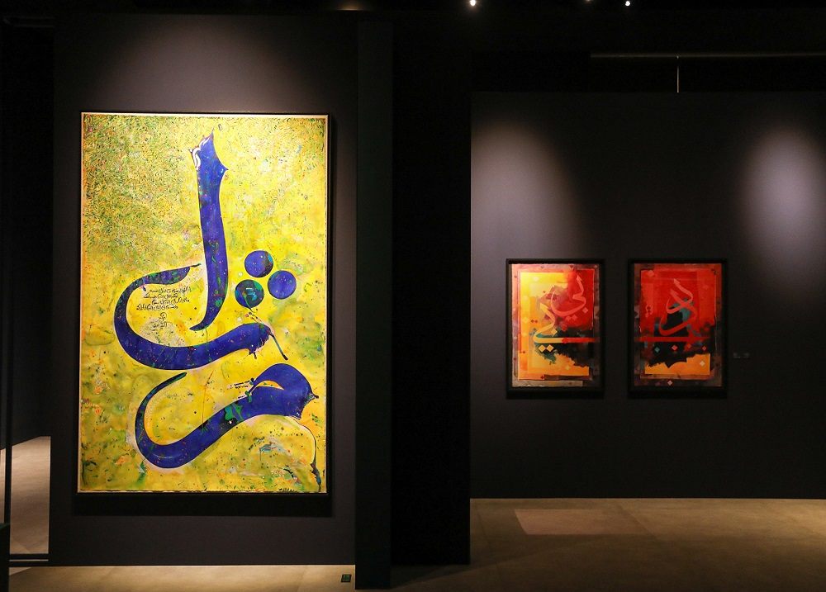

When Images Speak: Highlights from the Dubai Collection at Etihad Museum, installation view

- When Images Speak: Highlights from the Dubai Collection opens on 6 November at Etihad Museum
- The exhibition comprises artworks from the collections of 11 patrons of the Dubai Collection, providing a unique opportunity to engage with works that would not usually be accessible to the public
- Launching tomorrow, 4 November, the Digital Museum of the Dubai Collection constitutes an additional, virtual resource for the public to explore the works in the initiative (dubaicollection.ae)

Dubai, United Arab Emirates, 3 November 2021 – Dubai Collection’s first physical exhibition, When Images Speak: Highlights from the Dubai Collection, will open to the public on Saturday, 6 November at Etihad Museum in Dubai. Curated by Dr. Nada Shabout, the show features a selection of nearly 70 modern and contemporary art from the region, including museum-quality pieces by Baya Mahieddine, Naziha Selim, Fateh Moudarres, Dia al-Azzawi, and Abdul Qader Al Rais. Launching alongside the exhibition and live from tomorrow, 4 November, the Digital Museum of the Dubai Collection constitutes a unique educational resource for the general public and will feature the artworks and artists represented in Dubai Collection, alongside engaging editorial content.

The artworks in the exhibition have been lent into the Dubai Collection initiative from the collections of 11 patrons of Dubai Collection, providing a unique moment for residents and visitors to Dubai to engage with artworks that would not usually be publicly accessible. Alongside the opportunity to view pieces from The Private Collection of His Highness Sheikh Mohammed bin Rashid Al Maktoum and The Private Collection of Her Highness Sheikha Latifa bint Mohammed bin Rashid Al Maktoum, visitors will be able to see works from the A.R.M Holding Art Collection, The Cyba Audi Private Collection, the Snow Feinan Li Private Collection, the Ali & Rafia Malas Private Collection, The Mokbel Art Collection, the private collection of His Excellency Abdul Rahman bin Mohammed Al Owais, The Samawi Collection, The Private Collection of El Shaer Brothers, and the Charles Al Sidaoui, Private Collection, Dubai.

The exhibition unfolds across three thematic chapters, Abstract Variations, Societies in Transition, and Evoking the Environment, while tracing a historical survey of the negotiations through Arab modernism and its progression into contemporary trends. A central element of the exhibition is the digital display of historic issues of Al Tashkeel Magazine, documenting a dynamic academic and intellectual exchange between many of the artists on show at this exhibition and highlighting the UAE’s active role, not just as a creative hub for artists, but also in writing the art history of its region.

Muna Faisal Al Gurg, Chair of the Dubai Collection Curatorial Committee commented: “I am truly delighted to see the first physical exhibition of the Dubai Collection open at Etihad Museum. The museum provides the ideal backdrop for an initiative that embodies the innovative and progressive spirit of Dubai. The Dubai Collection team is exceptionally grateful to its patrons for entrusting their valuable artworks to the Dubai Collection; without their support, this one-of-a-kind historical survey of the art from our region would not have been possible. We are equally excited to be launching the Digital Museum of the Dubai Collection tomorrow, which constitutes a unique public educational resource.”

Live from tomorrow, 4 November, the Digital Museum of the Dubai Collection is a virtual repository for the works in the initiative, featuring a catalogue of works included in the collection, biographical information on each of the artists, as well as a host of essays and articles around the history of collecting in the UAE, profiles of prominent patrons involved in the initiative and further information around the works. The Digital Museum aims to be a resource for art lovers and researchers alike, providing unparalleled information on artworks from private and corporate collections, contextualized by academically rigorous and engaging editorial content. The Digital Museum will be accessible via: dubaicollection.ae

The Dubai Collection is the first institutional art collection of its kind. Introducing an innovative new system of sourcing, managing and governing artworks by patrons and collectors from across the emirate, public and private entities, as well as individuals are invited to contribute to the Dubai Collection by either acquiring artworks for loaning to the collection or lending artworks from their own collections.

The motivation behind the initiative is to support patronage, enrich Dubai’s artistic landscape, documenting its history and consolidating its position as a global cultural hub. By encouraging patrons to display art loaned by them to the Dubai Collection at publicly accessible venues, the initiative seeks to transform the emirate into a city-wide museum and bring the community closer to art and artists.

The Etihad Museum operation hours are daily from 10am – 8pm. Admission to the exhibition is included in your museum ticket.

-ENDS-

Notes to Editors

Media Contact:
Sana Yamlikha
ASDA’A BCW
Sana.Yamlikha@bcw-global.com

About the Dubai Collection
The Dubai Collection is an initiative developed by Dubai Culture & Arts Authority, run in partnership with Art Dubai Group. Held under the patronage of His Highness Sheikh Mohammed bin Rashid Al Maktoum, the Dubai Collection aims to build an institutional art collection for the city of Dubai by using a new and innovative format. The collection is being built in partnership with patrons who support the initiative by lending artworks whilst always retaining legal ownership over them. The Dubai Collection engages with themes connected with the historical development of the Emirate and the UAE and reflects the values of openness, diversity and interconnectedness as embodied in the spirit of its home. Whilst it will focus on the UAE and the region, it is an international collection with no geographical restrictions.
dubaicollection.ae | #DubaiCollection #WhenImagesSpeak

About The Curator
Dr. Nada Shabout is a Regent Professor of Art History and the Coordinator of the Contemporary Arab and Muslim Cultural Studies Initiative (CAMCSI) at the University of North Texas. She is the founding president of the Association for Modern and Contemporary Art from the Arab World, Iran and Turkey (AMCA) and founding director of Modern Art Iraq Archive (MAIA). She is a curator and author of numerous essays and books, including Modern Arab Art: Formation of Arab Aesthetics, 2007; co-editor with S. Mikdadi, New Vision: Arab Art in the 21st Century, 2009; and co-editor With A. Lenssen and S. Rogers, Modern Art in the Arab World: Primary Documents, Museum of Modern Art, 2018. Notable among exhibitions she has curated: Sajjil: A Century of Modern Art, 2010; traveling exhibition, Dafatir: Contemporary Iraqi Book Art, 2005-2009; and co-curator, Modernism and Iraq, 2009. She is currently working on a new book project, Demarcating Modernism in Iraqi Art: The Dialectics of the Decorative, 1951-1979, under contract with the American University in Cairo Press. Shabout is on the Board of Directors, Visual Art Commission, Ministry of Culture, Saudi Arabia; the Board of The Academic Research Institute in Iraq (TARII); and the College Art Association (CAA) Board of Directors (2020-2024). Shabout is the recipient of the 2020 Kuwait Prize for Arts and Literature from the Kuwait Foundation for the Advancement of Sciences.

About Dubai Culture & Arts Authority (Dubai Culture)
On 8th March 2008, His Highness Sheikh Mohammed bin Rashid Al Maktoum, UAE Vice President and Prime Minister and Ruler of Dubai, launched Dubai Culture & Arts Authority (Dubai Culture). The mandate of the Authority is to serve as a dedicated entity for culture, arts, heritage, and literature in the Emirate of Dubai, and to drive the growth of the city’s artistic and cultural landscape. Dubai Culture focuses on establishing Dubai as a regional and global centre for creativity, and also seeks to enhance the city's cultural identity in order to drive the creative economy. The Authority strives to enhance the quality of life for Dubai residents to help achieve a key pillar of the Dubai Plan 2021 objectives, which is to create a city of happy, creative, and empowered people. Under the leadership of Her Highness Sheikha Latifa bint Mohammed bin Rashid Al Maktoum, Chairperson of Dubai Culture, the Authority has played an integral role in reinforcing Dubai’s position as a vibrant global centre for creativity, and in enhancing the city's cultural identity.

About Art Dubai Group
Established in 2007 the Art Dubai Group (ADG) is a public/private partnership with a mission to develop innovative sustainable ecosystems that support the development & promotion of vibrant creative scenes. The company owns and operates some of the region’s most successful cultural events that include Art Dubai, Dubai Design Week and the Global Grad Show, as well as offering its industry expertise to private and government institutions.

About Etihad Museum
A dynamic 21st century museum, Etihad Museum is focused on inspiring its visitors with the story of the founding of the UAE. The 25,000 m2 landmark is befittingly located at the very place where the UAE was founded in 1971. Through a unique visitor journey, the various pavilions house experience-driven exhibitions, interactive programmes and education initiatives that explore the chronology of events that culminated in the unification of the Emirates in 1971, with a key emphasis on the period between 1968 and 1974.

