Press Release
Date of issue: 25 October 2021

The Dubai Collection Announces First Physical Exhibition

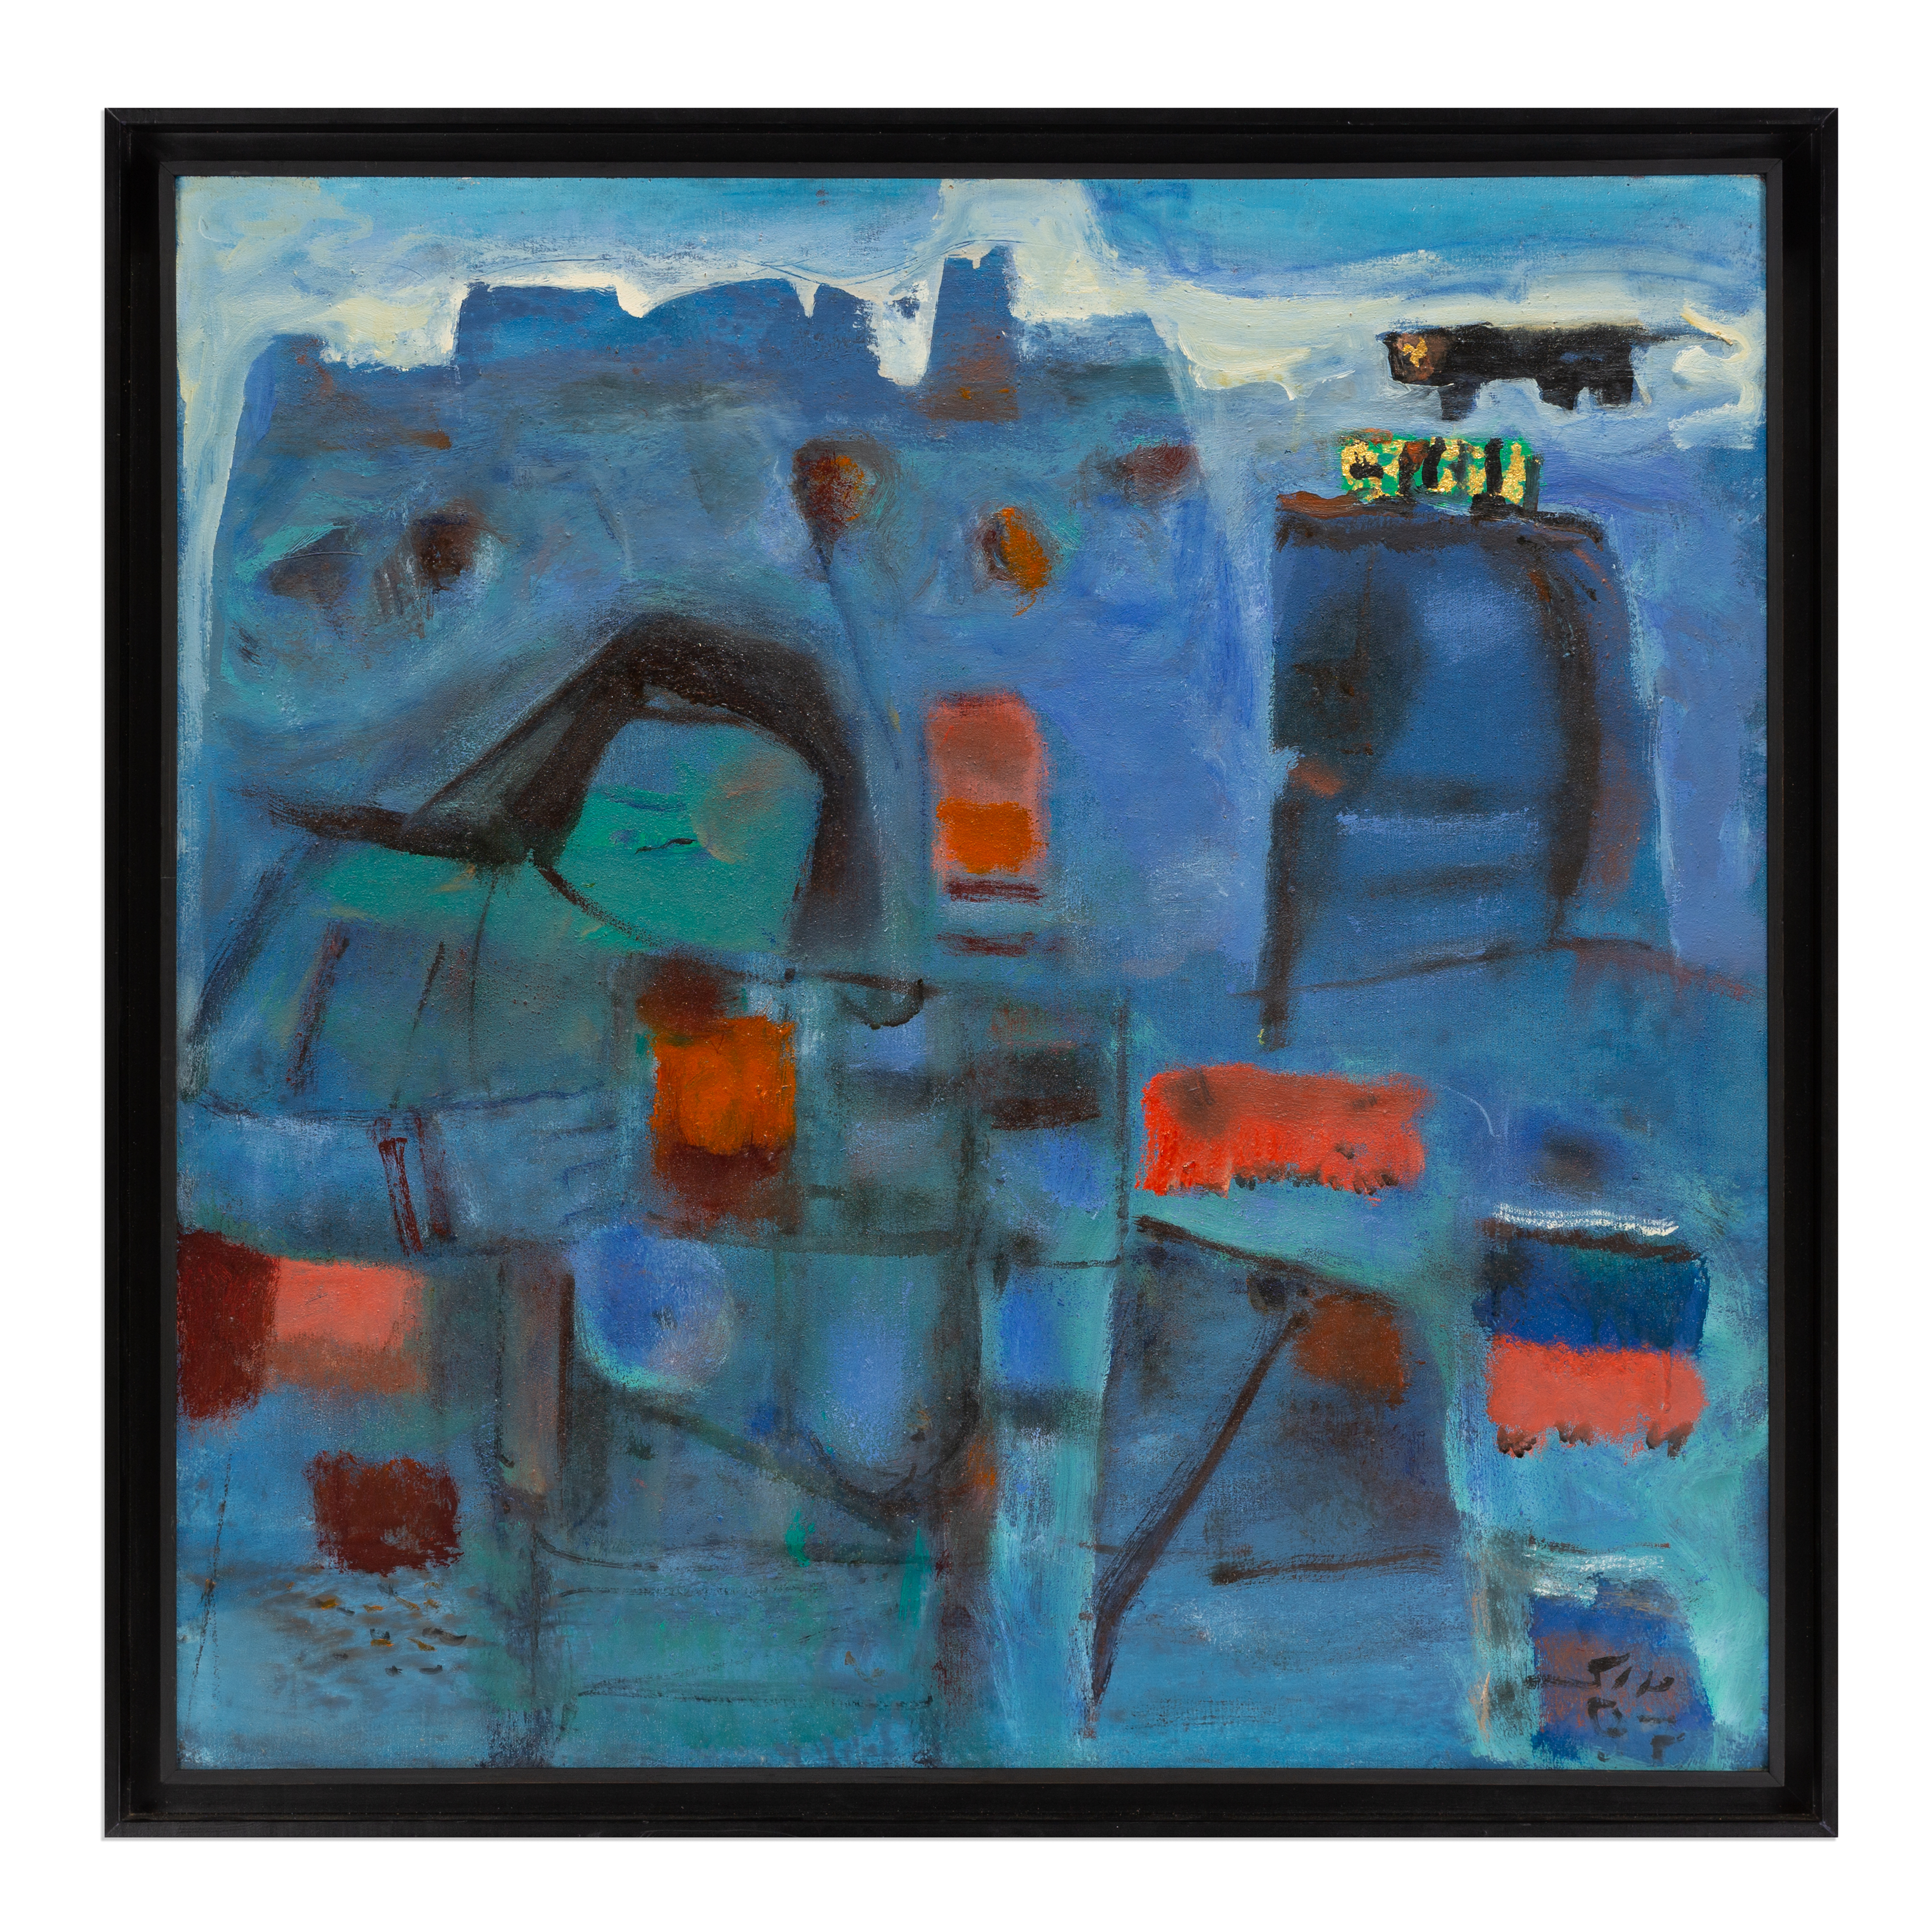
Fateh Moudarres, Levant Borders, 1997. From the private collection of His Highness Sheikh Mohammed Bin Rashid Al Maktoum

- When Images Speak: Highlights from the Dubai Collection will open at Etihad Museum on 6 November
- Featuring modern and contemporary artworks from the region, the exhibition tells the story of Arab modernism and its progression into contemporary art

Dubai, United Arab Emirates, 25 October 2021 – The Dubai Collection today announces details of its first physical exhibition featuring a selection of its newly accessioned artworks. Built through an innovative partnership model, the collection brings together exceptional works of art from both private and corporate collections for public appreciation and international scholarship. Curated by Dr. Nada Shabout, the exhibition When Images Speak: Highlights from the Dubai Collection will present a selection of modern and contemporary art from across the region, tracing a historical survey of the negotiations through Arab modernism and its progression into contemporary trends, while highlighting the Gulf’s role in the documenting of art history as it was being written.

Commenting on the announcement, HH Sheikha Latifa bint Mohammed bin Rashid Al Maktoum, Chairperson of Dubai Culture & Arts Authority and Chair of the Dubai Collection’s Steering Committee, said, “The opening of When Images Speak is an important milestone in the Dubai Collection’s trajectory, as it presents the actualisation of an innovative initiative conceptualised right here in Dubai. This could not have happened without the trust of our patrons and their belief in the ambition of this project that seeks to bring art in the Emirate to the public and public spaces in the UAE and abroad; connect patrons with locally based artists; and collectively build Dubai’s art collection supporting its cultural sector.”

She continued, “We are delighted to feature in our first exhibition When Images Speak, artworks from the collection of, His Highness Sheikh Mohammed bin Rashid Al Maktoum, Vice President and Prime Minister of the United Arab Emirates and Ruler of Dubai. Having His Highness’s collection as a part of Dubai Collection’s first ever physical exhibition reflects His Highness’s commitment and support to the growth of the creative sector in Dubai. The exhibition will present a rich narrative of 20th century Arab art, which will also highlight the role the Gulf played in documenting this artistic period. We look forward to welcoming the public to our inaugural exhibition at the Etihad Museum in November.”

Commenting on the exhibition, Dr. Nada Shabout, Curator of When Images Speak, added: “With the aim of creating a historical survey of modern and contemporary art from the region, When Images Speak will feature some of the most influential and progressive artists, all of whom played a pivotal role in shaping the modern movements in the region and reflect the socio-cultural dynamics of their time. The 20th century was one of major shifts that resulted in founding the different countries of the Arab World, following periods of colonization and struggles for independence. In forming national identities and iconography, those artists played a vital role that further aided in the construction of the national consciousness.”

The exhibition will unfold across three thematic chapters, with the artworks acting as archival records of their time and narrating the history of art from the region over the last decades, while many of the groupings overlap and intersect thematically.

Entitled Abstract Variations, and featuring pivotal artworks by prominent artists from region including Dia al-Azzawi and Omar El Nagdi, the first chapter of the exhibition will survey the topic of abstraction in modern Arab art. A heated topic of discussion and loaded political category among Arab artists during the mid- and second half of the 20th century, abstraction was a way of claiming identity and a form of resistance for some, while others questioned its ability to connect with the public and argued it prohibited art from playing a more direct role in national education. Abstraction was seen as a way to move towards the future, but also a way of reconnecting with the past.

The second chapter in the exhibition, Societies in Transition, features artists’ investigations into society, history, family, mythologies, and culture. Works by artists such as Baya Mahieddine, Naziha Selim, and Asaad Arabi articulate the artists’ understanding and dialogues of the self through societal relationships as well as local struggles for independence and the formation of nations in a global context. Internationalism became a particularly important notion during this time, with artists seeking connection and engaging with movements from Europe as much as from other areas of the world, such as the Indian subcontinent. Defying a Western-imposed Orientalist narrative, these artists represented their own realities and people, and their works speak to resilience and creativity in the face of struggles.

Evoking the Environment will be the third and final chapter of the exhibition. Through works by Fateh Moudarres, Abdul Qader Al Rais, and Nejib Belkhodja, amongst others, it reveals how painting cities became a method of constructing, and documenting, an ideal imaginary: the nation; while at others it registered the ongoing transformations of small towns and villages into larger urban spaces, as each country developed its modern identity.

A critical element of the exhibition will be the focus on the UAE’s role in documenting a dynamic academic and intellectual exchange between many of the artists on show in this exhibition as well as the country’s active role, not just as a creative hub for artists, but also in writing the art history of its region.

Published alongside the show, an eponymous digital catalogue, and featuring research by Dr. Nada Shabout, will help contextualize the works on show.

Guided by an inclusive and collective outlook, the Dubai Collection is an opportunity for patrons to showcase their collections and for artists to have their artworks included in a publicly accessible platform. The Collection charts the history of the city and highlights Dubai’s vibrant and progressive identity, reaffirming its position as an international hub for art and culture.

The first physical exhibition will coincide with the launch of the Digital Museum of the Dubai Collection, which will feature a catalogue of works included in the Collection and biographical information on each of the artists, alongside a host of editorial content around the history of collecting in the UAE, profiles of prominent patrons involved in the initiative and further information around the works.

The Dubai Collection was developed in collaboration with the Art Dubai Group which continues to be the primary point of contact for its full operations, running activities on behalf of the Dubai Culture & Arts Authority.

When Images Speak: Highlights from the Dubai Collection will open at the Etihad Museum on 6 November.

The Etihad Museum operation hours are daily from 10:00 am – 08:00 pm. Admission to the exhibition is included in your museum ticket.

-ENDS-

Notes to Editors

Media Contact:
Lina Haytham Zain Aldin
Dubai Culture & Arts Authority, Senior Specialist Corporate Communication
Lina.Zain@dubaiculture.ae

About the Dubai Collection
The Dubai Collection is an initiative developed by Dubai Culture & Arts Authority, run in partnership with Art Dubai Group. Held under the patronage of His Highness Sheikh Mohammed bin Rashid Al Maktoum, the Dubai Collection aims to build an institutional art collection for the city of Dubai by using a new and innovative format. The collection is being built in partnership with patrons who support the initiative by lending artworks whilst always retaining legal ownership over them. The Dubai Collection engages with themes connected with the historical development of the Emirate and the UAE and reflects the values of openness, diversity and interconnectedness as embodied in the spirit of its home. Whilst it will focus on the UAE and the region, it is an international collection with no geographical restrictions.
dubaicollection.ae | #DubaiCollection

About The Curator
Dr. Nada Shabout is a Regent Professor of Art History and the Coordinator of the Contemporary Arab and Muslim Cultural Studies Initiative (CAMCSI) at the University of North Texas. She is the founding president of the Association for Modern and Contemporary Art from the Arab World, Iran and Turkey (AMCA) and founding director of Modern Art Iraq Archive (MAIA). She is a curator and author of numerous essays and books, including Modern Arab Art: Formation of Arab Aesthetics, 2007; co-editor with S. Mikdadi, New Vision: Arab Art in the 21st Century, 2009; and co-editor With A. Lenssen and S. Rogers, Modern Art in the Arab World: Primary Documents, Museum of Modern Art, 2018. Notable among exhibitions she has curated: Sajjil: A Century of Modern Art, 2010; traveling exhibition, Dafatir: Contemporary Iraqi Book Art, 2005-2009; and co-curator, Modernism and Iraq, 2009. She is currently working on a new book project, Demarcating Modernism in Iraqi Art: The Dialectics of the Decorative, 1951-1979, under contract with the American University in Cairo Press. Shabout is on the Board of Directors, Visual Art Commission, Ministry of Culture, Saudi Arabia; the Board of The Academic Research Institute in Iraq (TARII); and the College Art Association (CAA) Board of Directors (2020-2024). Shabout is the recipient of the 2020 Kuwait Prize for Arts and Literature from the Kuwait Foundation for the Advancement of Sciences.

About Dubai Culture & Arts Authority (Dubai Culture)
On 8th March 2008, His Highness Sheikh Mohammed bin Rashid Al Maktoum, UAE Vice President and Prime Minister and Ruler of Dubai, launched Dubai Culture & Arts Authority (Dubai Culture). The mandate of the Authority is to serve as a dedicated entity for culture, arts, heritage, and literature in the Emirate of Dubai, and to drive the growth of the city’s artistic and cultural landscape. Dubai Culture focuses on establishing Dubai as a regional and global centre for creativity, and also seeks to enhance the city's cultural identity in order to drive the creative economy. The Authority strives to enhance the quality of life for Dubai residents to help achieve a key pillar of the Dubai Plan 2021 objectives, which is to create a city of happy, creative, and empowered people. Under the leadership of Her Highness Sheikha Latifa bint Mohammed bin Rashid Al Maktoum, Chairperson of Dubai Culture, the Authority has played an integral role in reinforcing Dubai’s position as a vibrant global centre for creativity, and in enhancing the city's cultural identity.

About Art Dubai Group
Established in 2007 the Art Dubai Group (ADG) is a public/private partnership with a mission to develop innovative sustainable ecosystems that support the development & promotion of vibrant creative scenes. The company owns and operates some of the region’s most successful cultural events that include Art Dubai, Dubai Design Week and the Global Grad Show, as well as offering its industry expertise to private and government institutions.

About Etihad Museum
A dynamic 21st century museum, Etihad Museum is focused on inspiring its visitors with the story of the founding of the UAE. The 25,000 m2 landmark is befittingly located at the very place where the UAE was founded in 1971. Through a unique visitor journey, the various pavilions house experience-driven exhibitions, interactive programmes and education initiatives that explore the chronology of events that culminated in the unification of the Emirates in 1971, with a key emphasis on the period between 1968 and 1974.

