ART DUBAI 2021 IS NOW OPEN
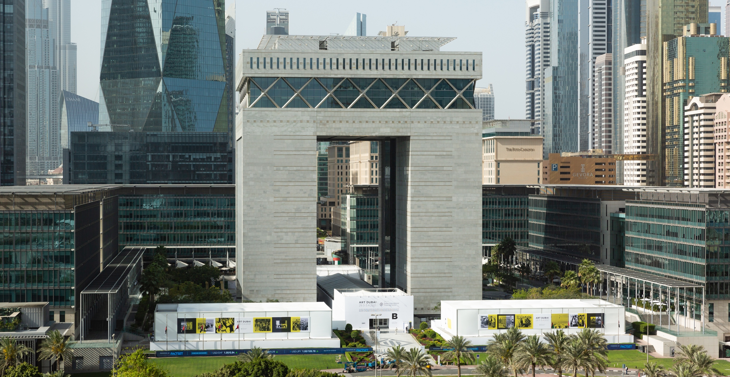
Art Dubai is held under the patronage of His Highness Sheikh Mohammed bin Rashid Al Maktoum,
Vice President and Prime Minister of the UAE and Ruler of Dubai.
- Art Dubai has returned for its 14th edition from 29 March - 3 April, produced in accordance with the highest safety protocols including new innovations to ensure a safe and secure environment
- Taking place in a new location under the iconic Gate Building at Dubai International Financial Centre (DIFC), Art Dubai 2021 is one of the first major physical art fairs to take place since the start of the pandemic
- 50 galleries from 31 countries are showcasing a diverse selection of artworks with a focus on artists and practices from the Middle East and the Global South
- A new innovation to the fair model, the Remote Participation Programme uses technologies to digitally connect participating galleries unable to travel to Dubai in person with fair visitors
- Programme highlights include a curated Sculpture Park, a new Film Programme and a showcase of works from the eighth edition of Campus Art Dubai
Dubai, United Arab Emirates, 30 March 2021: Held under the patronage of His Highness Sheikh Mohammed bin Rashid Al Maktoum, Vice President and Prime Minister of the UAE and Ruler of Dubai and hosted by Dubai International Financial Centre (DIFC), Art Dubai returns as one of the first in-person art international fairs of 2021, featuring 50 leading Contemporary and Modern galleries from 31 countries.

Reaffirming the fair’s commitment to providing a physical platform and marketplace for artists and galleries from across the Global South, visitors will encounter galleries from across the Middle East and South and East Asia, including from Lebanon, Palestine, Turkey, Saudi Arabia, India, Vietnam and Philippines. There is also strong representation from across the African continent including galleries from Egypt, Ethiopia, Ghana, Kenya, Morocco and Tunisia. The fair will feature nine of Dubai’s top galleries as well as galleries from major and emerging international art centres.

Staged in a purpose-built venue at the iconic Gate Building in Dubai International Financial Centre (DIFC), Art Dubai will operate according to the highest COVID-19 safety protocols. Alongside standard social distancing procedures and regular testing of participants, the fair has introduced extra precautions to manage capacity to offer a safe and flexible environment for all. New measures in place include extending the fair dates and opening hours and the new Art Dubai App, allowing visitors to book dedicated time slots in advance to guarantee entry, stay up-to-date with the latest news and announcements, explore the exhibiting galleries and artworks and view the full programme.

H.E. Essa Kazim, Governor of DIFC, said: “Dubai’s inspiring status as a regional business and cultural hub is driven by the vision of His Highness Sheikh Mohammed bin Rashid Al Maktoum, UAE Vice President and Prime Minister and Ruler of Dubai, to strengthen opportunities for all in every sector. At DIFC, we have delivered on this vision by creating an iconic centre of finance that also encourages arts and culture through our commissioned works of art, ongoing cultural events and now hosting Art Dubai. The event will further shine the spotlight on the city and add to its reputation globally.”
Arif Amiri, CEO of DIFC Authority, said: “Art has always been an important part of Dubai and DIFC’s cultural offering. This year’s Art Dubai reinforces this message with the global art community especially because it provides one of the first opportunities following the pandemic for artists from around the world to collaborate, network and meet prospective buyers. The event also adds to the recently announced Dubai 2040 Urban Master Plan given it enhances the quality of life of residents and reinforces the city’s appeal as a preferred place to live in, work and thrive. Hosting the fair contributes to DIFC’s reputation as one of Dubai’s leading lifestyle destinations and complements our ongoing art programme.”
Pablo del Val, Artistic Director of Art Dubai, said: “The arts sector has – like so many others – been significantly impacted by the events of the last 12 months and the central role that Art Dubai plays within both the cultural ecosystem of the UAE and the wider region has become more apparent than ever. By working closely with our community and by adopting Dubai’s progressive and ‘can-do’ way of thinking, we are delighted that we have been able to open doors to an in-person art exhibition and again welcome our audiences back to Art Dubai.”

In order to support the galleries exhibiting, the fair has introduced a number of new innovations. These include the Remote Participation Programme, which uses digital technologies to connect those participating galleries unable to travel to Dubai in person with fair visitors along with providing video introduction to the artworks on show; and a new payment scheme whereby galleries pay their participation fees based on their success at the fair.

Benedetta Ghione, Executive Director of Art Dubai, said: “Our team has been working tirelessly over the past year to innovate and re-think the fair model, which will be apparent throughout Art Dubai 2021. We have a new venue for this year, an innovative payment model for participating galleries and a remote participation programme specficially created for those galleries unable to travel to Dubai. Although some of these will be one-off initiatives reflecting the current times, others we expect to enhance for future editions”.

The fair will take place between 29 March and 3 April. The first three days will be by invitation only and the fair will open to the public from 1 – 3 April. Access to the fair will be via the new Art Dubai App where tickets can be purchased for AED 25 and children enter for free.

Other elements of Art Dubai’s 2021 programme include:

Sculpture Park

A curated Sculpture Park surrounding the DIFC Gate Building features large-scale installations by ten artists including: pioneering conceptual Emirati artists Mohamed Ahmed Ibrahim and Hussain Sharif, Saudi artist Rashed Al Shashai, Iraqi painter and sculptor Dia Al-Azzawi and Algerian sculptor, print-maker and ceramicist Rachid Koraïchi alongside contemporary Mozambican artist Gonçalo Mabunda, Greek conceptual sculptor Costas Varotsos, Indian architect Tarik Currimbhoy, French conceptual artist Bernar Venet and Argentine-French multidisciplinary artist Pablo Reinoso.

Film Programme and 50 Years United Exhibition

As part of this year’s curatorial projects, Art Dubai will present a Film Programme comprised of screening stations located along DIFC’s Gate Avenue, featuring single-channel films produced by over 20 regional and international artists. Each is thematically categorised to curate a specific experience for the viewer that includes: Nature, Journeys, Dystopias, Conversations, Performances and Animations, among others. A station is dedicated to Art Dubai Portraits, an ongoing film series in partnership with BMW Middle East that provides perspectives into the lives and workspaces of artists connected to the fair.

Also in Gate Avenue, a recollective black and white photographic exhibition showcases images dating back to 2 December 1971, taken by Ramesh Shukla and the inspiration behind Art Dubai’s 2021 graphic campaign. 50 Years United is a visual commemoration of the upcoming 50th anniversary of the nation and offers a journey down memory lane, with portraits of the Founding Fathers, vintage landmarks and traditional customs and heritage.

Campus Art Dubai 8.0

Curated by Munira Al Sayegh, an exhibition titled Plants, Animals, Minerals presents the culmination of Campus Art Dubai 8.0, that was supported by Dubai Culture & Arts Authority and hosted by A.R.M. Holding. The latest edition of the six-month seminar and residency programme - providing Emirati and UAE-based artists with educational and professional opportunities - features five selected artists’ responses to the theme of symbiotic life in a parasitic world. The participating artists are: Ameena AlJarman, Layan Attari, Nahla Tabbaa, Zahra Jewanjee, and Zena Adhami.
Ithra Art Prize

The King Abdulaziz Center for World Culture (Ithra) celebrates contemporary art and artists through the Ithra Art Prize. Launched in 2017 in collaboration with Art Dubai, the winning artwork premieres at the yearly event. This is the third iteration of the prize which is awarded annually to Saudi and Saudi-based contemporary artists and aims to fund, promote and showcase them globally. The latest winner is the Saudi artist Fahad bin Naif, for his installation ‘Rakhm’, which means ‘incubation’ in Arabic. Unveiled at Art Dubai 2021, it is the first opportunity for the public to enjoy it. The installation aims to conceptually preserve a nursery as both an urban typology and its ‘incubatees’, as an environmental micro-economy. Mirroring both the sensitivity and urgency of the content, safely and carefully incubating an intelligent green infrastructure, Rakhm is a polytunnel nursery that mimics the existing urban nurseries in the Kingdom with endemic plants and flowers instead of conventional foreign houseplants.

Art Dubai’s 2021 programme also includes new exhibitions by key partners of the fair; Switzerland is presenting an outdoor installation titled Swiss Fog Magnified, featuring over one thousand crystal glass spheres and reinterpreting a highlight that awaits visitors in the Swiss Pavilion at Expo 2020 Dubai. Commissioned by Maison Ruinart to express his vision of the brand, its heritage and savoir-faire, British artist David Shrigley presents a series of indoor and outdoor artworks with an offbeat and unrelenting sense of humour, acting as an effervescent eye-opener to environmental concerns. Luxury Italian brand Salvatore Ferragamo will stage an activation, showcasing their Spring/ Summer 2021 collection and integrating a visual experience and short film shot in Milan by award-winning filmmaker Luca Guadagnino.

-Ends-

Notes to Editors

The new Art Dubai app is available to download on the App Store and Google Play.

Tickets are available to purchase via the Art Dubai app. Due to social distancing measures the venue capacity is restricted, it will therefore be mandatory for visitors to book their ticket and time slot in advance.
Adult tickets cost AED 25. Visitors under 18 years of age and university students can enter free of charge upon booking a child or student ticket.
The full Art Dubai 2021 gallery list can be viewed here.

Fair dates & timings:
Monday, 29 March (Art Dubai Preview, by invitation only)
Tuesday, 30 March (By invitation only)
Wednesday, 31 March (By invitation only)
Thursday, 1 April: 1–9pm
Friday, 2 April: 1–9pm
Saturday, 3 April: 11am–7pm
Location:
Gate Building, Dubai International Financial Centre (DIFC)
Dubai, United Arab Emirates
For map click here.
Visit artdubai.ae and follow @artdubai | #ArtDubai2021 on social media to stay updated.
For any press enquiries, please contact: press@artdubai.ae

About Art Dubai:

Art Dubai is the Middle East’s leading art fair for the local, regional and international art world. Since 2007 Art Dubai has championed art and artists from across the Middle East, MENASA (Middle East, North Africa & South Asia) and the Global South, broadening conversations about art beyond traditional Western-led geographical scopes and narratives.

In keeping with Dubai’s reputation as a hub for innovation, incubation and knowledge exchange, Art Dubai provides a sustainable platform for artists and meaningful engagement with the rich cultural heritage and contemporary art practices of the region. Featuring Contemporary and Modern gallery sections, annual artist-driven commissions, collector and education programmes and artist residencies, the fair fosters a culture of discovery and new global perspectives.

Art Dubai 2021 is hosted by Dubai International Financial Centre and is sponsored by Julius Baer. The Dubai Culture & Arts Authority (Dubai Culture) is the fair’s strategic partner.
For further information, please visit artdubai.ae

About Dubai International Financial Centre (DIFC)
Dubai International Financial Centre (DIFC) is one of the world’s most advanced financial centres, and the leading financial hub for the Middle East, Africa and South Asia (MEASA), which comprises 72 countries with an approximate population of 3 billion and a nominal GDP of USD 7.7 trillion.

With a 16-year track record of facilitating trade and investment flows across the MEASA region, the Centre connects these fast-growing markets with the economies of Asia, Europe and the Americas through Dubai.
DIFC is home to an internationally recognised, independent regulator and a proven judicial system with an English common law framework, as well as the region’s largest financial ecosystem of around 27,000 professionals working across over 2,900 active registered companies – making up the largest and most diverse pool of industry talent in the region.

The Centre’s vision is to drive the future of finance. Today, it offers one of the region’s most comprehensive FinTech and venture capital environments, including cost-effective licensing solutions, fit-for-purpose regulation, innovative accelerator programmes, and funding for growth-stage start-ups.

Comprising a variety of world-renowned retail and dining venues, a dynamic art and culture scene, residential apartments, hotels and public spaces, DIFC continues to be one of Dubai’s most sought-after business and lifestyle destinations.

For further information, please visit difc.ae

