Press Release
Date of issue: December 16, 2019

Fahad bin Naif Announced as the Winner of the Third Edition of the Ithra Art Prize:
A Collaboration between the King Abdulaziz Center for World Culture and Art Dubai

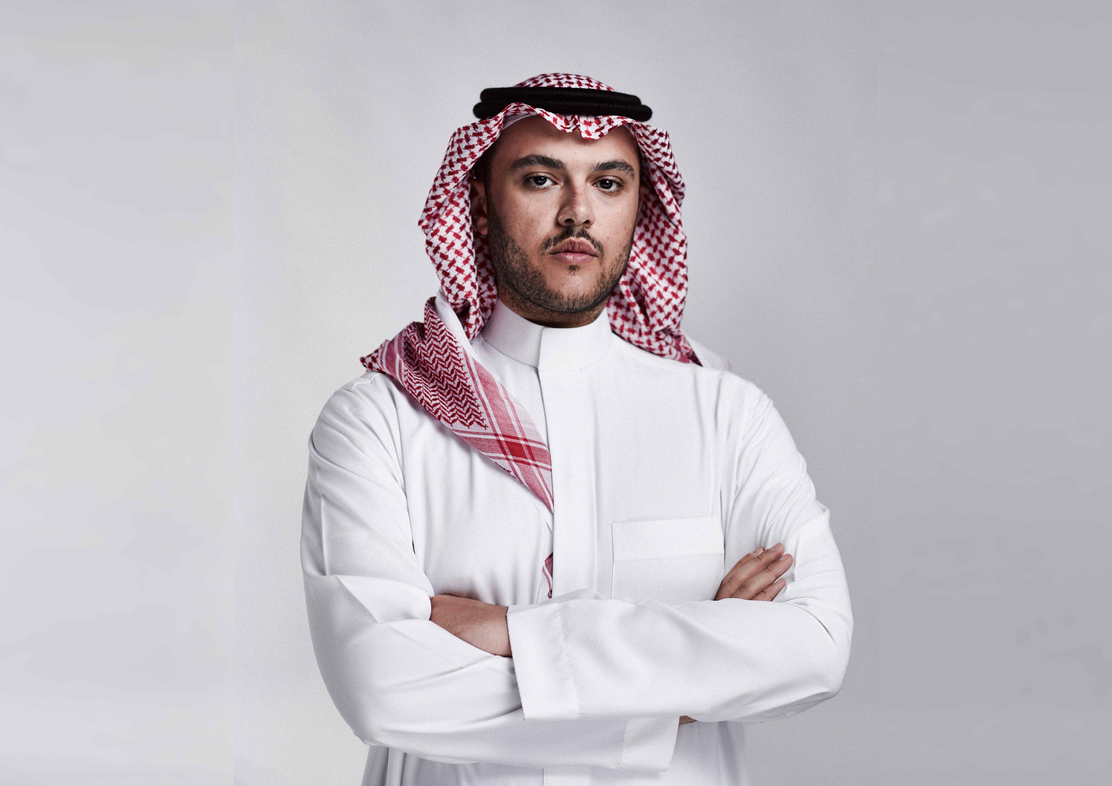
Photo of Ithra Prize Winner, Fahad bin Naif. Courtesy of artist.

December 16, 2019, Dhahran, Saudi Arabia – The King Abdulaziz Center for World Culture (Ithra) and Art Dubai announce Saudi-based Fahad bin Naif as the winner of the third edition of the Ithra Art Prize.
Since its launch in 2017, the Ithra Art Prize has served as a platform to accelerate, empower and promote the work of Saudi contemporary artists on a global scale. In partnership with Art Dubai,

Ithra invites all Saudi and Saudi-based artists and collectives to submit proposals via an open call each year. The winner of the prize receives up to 100,000USD to implement their proposed artwork, which will be unveiled at Art Dubai’s 14th edition, happening March 25 – 28, 2020, before moving to Ithra as part of the center’s growing permanent collection.
Last year, Saudi-born Daniah Al Saleh was announced as the winner of the second edition of the Ithra Art Prize, with her project on display at Art Dubai 2019. Her project, titled Sawtam, was a digital audio-visual presentation based on the phonemes of the Arabic language, which created a digital wind chime effect.
A testament to the growing impact and notability of the Prize, the third edition of the competition received twice the number of applications as 2019’s edition. This year’s winning proposal belongs to Saudi-based Fahad bin Naif, and was chosen by a panel composed of Ithra’s curatorial team and international art experts, Eiman Elgibreen, Maya El Khalil, Nada Shabout, Reem Fadda and Tarek Abou El Fetouh.
An artist, architect, urban designer and researcher, Fahad bin Naif creates art projects with architectural elements and is deeply engaged in the Saudi and regional cultural scene. He holds a bachelor’s degree in Architecture from Central Saint Martins-University of the Arts London.
Bin Naif’s installation — Rakhm which means ‘incubation’ in Arabic — aims to conceptually preserve a nursery as both an urban typology and its ‘incubatees’ as an environmental micro-economy. The title of the installation mirrors both the sensitivity and urgency of the content, safely and carefully incubating an intelligent green infrastructure. Rakhm is a Polytunnel nursery that mimics the existing urban nurseries in the Kingdom with endemic plants and flowers instead of conventional foreign houseplants. Unlike most nurseries, however, the viewer can only experience the exterior of the nursery, which mirrors the general local approach to xeriscaping wherein local foliage is not an environmental or aesthetic priority. The experience of the viewer from the outside also highlights the notion that contextually there is very little interaction between local human inhabitants and local plant-life and the importance on an environmental level of changing this narrative.
Laila Faddagh, Head of Ithra Museums comments on the announcement: “We are thrilled to see the Ithra Art Prize grow in its third edition. Our key commitment remains in encouraging and providing a platform for Saudi- and Saudi-based artistic talent to prosper and flourish, and we are delighted to partner with Art Dubai once more on this Prize. The committee’s response to Fahad bin Naif’s work was enthusiastic, and we were touched by the contextualised thoughtfulness and interdisciplinary approach the artist has taken when developing his concept. We are looking forward to supporting him as he further evolves his work and we anticipate an exciting reveal of Rakhm at Art Dubai 2020.”
Winning artist Fahad bin Naif added: "It is an honour and a privilege to have been by selected by the prestigious jury panel as the winner of the Ithra Art Prize 2020. This opportunity, as a Saudi artist and architect who is also quite invested in the cultural, social and urban fabric of our society, is deeply meaningful. Initiatives like the Ithra Art Prize further highlight the Kingdom’s commitment to nurturing artistic talent and building our creative ecosystem both locally and globally."
Fahad bin Naif will spend the next months finalising his work which will be unveiled at Art Dubai, from March 25 – 28 2020 and later join Ithra’s permanent art collection.

Ithra, a cultural and creative hub based in Dhahran, Saudi Arabia, offers programmes and compelling experiences while enhancing and showcasing local and global talents. It proudly made TIME Magazine’s 2018 list of one of the world’s best 100 places to visit.
—END—

MEDIA CONTACTS
Mona Al Shehri
Media Relations, Ithra
mona.shehri@aramco.com
+966 504967179

Lena Kassicieh
Media Relations, Art Dubai
lena@artdubai.ae
+971 5660 96209

NOTES TO EDITORS
About the Artist: Fahad bin Naif
Fahad is an architect and an urban designer who creates architecturally-conscious art projects. He has been working professionally after completing his Bachelor’s degree in Architecture from Central Saint Martins – University of the Arts London. His final year project “The Islamic Cultural Center of Peckham” was nominated for a Royal Institute of British Architects’ regional award. Fahad is part of the regional art and design scene; creating artwork, conducting urban research and seminars, participating in group exhibitions and curating independent art shows.
About the Ithra Art Prize
Launched in 2017 by the King Abdulaziz Center for World Culture (Ithra) in collaboration with Art Dubai, the Prize is awarded to emerging Saudi and Saudi-based talent in contemporary art as a means to fund, promote and offer Saudi artists a global platform. Sharjah-based, Saudi Arabian artist Ayman Zedani was the winner of the first edition of the Prize and was also part of the jury for the second edition of the Prize. The selection committee is made up of Saudi as well as international experts.As part of a collaboration between Ithra and Art Dubai, the winning work is unveiled at Art Dubai each year, and subsequently joins Ithra’s prestigious permanent collection.

About the King Abdulaziz Center for World Culture
The King Abdulaziz Center for World Culture’s building with its unique architecture rises as a shining beacon of knowledge in Dhahran’s skyline. The building, which is an initiative by Saudi Aramco, is significantly located near the Prosperity Well where oil was first discovered in commercial quantities in the Kingdom of Saudi Arabia. The purpose of this ambitious initiative is to accelerate the Kingdom’s transformation into a knowledge-based economy as envisioned by HM King Abdullah who laid the foundation stone for this iconic building.
The Center is the first incubator of knowledge of its kind in the Kingdom of Saudi Arabia. It brings together under its roof many programs that aim to create a positive and tangible impact in the fields of knowledge and culture by preparing the national talents for the knowledge-based and innovation-based creative industries.
The Center features a modern architectural design, state-of-the-art technologies, unique learning tools, and enriching programs. It is an important platform for explorers, intellectuals, innovators, and leaders. The Center – a diverse cultural space – has a 21st century Library, an Idea Lab, a Children Museum, an Oasis for children, a Four-Gallery Museum, an Archives Gallery, an Energy Exhibit, a Knowledge Tower, a Great Hall, a Theater and a Cinema, which stands at its heart to offer educational programs that cater to all age groups. The Center’s programs were all designed to inspire the community, enrich the culture, and support our community which is taking steady steps toward establishing a knowledge-based economy.
About Art Dubai
Art Dubai is the Middle East’s leading international art fair, taking place every March in Dubai, UAE.
Over the past 13 years, Art Dubai has cemented its role in being a major catalyst in the local, regional and international conversations on art from the Middle East and surrounding region (MENASA – Middle East, North Africa & South Asia), and putting art from these territories onto the global map.
As one of the world’s most international art fairs, Art Dubai has further expanded its commitment to cultivating a culture of discovery, offering exciting new global perspectives and broadening conversations about art beyond traditional western-led geographical scopes and narratives. Featuring four gallery sections (Contemporary, Modern, Bawwaba and Residents), the fair drives meaningful engagement with the rich cultural heritage and contemporary art practices of the region and extending to territories across Southeast Asia, the African continent, Latin America and Australasia.
In its role as talent incubator, Art Dubai has been the launch pad and development platform of the successful careers of artists, curators and art professionals, and continues to celebrate art excellence through its extended fair Programming, artist Commissions and initiatives such as the Ithra Art Prize, while platforms such as UAE NOW highlight community building and promote grassroots perspectives by showcasing the Gulf’s emerging, independent, self-organised art communities. Art Dubai also works closely with its Partners in producing innovative art programming and supporting the cultural community.
Art Dubai’s mission extends to cultivating an ecosystem of not only art, but also education, mentorship and thought leadership, through programmes such as the Global Art Forum, an extensive talks programme and Campus Art Dubai. Through unique platforms such as the Invited Curators Programme, we aim to foster cross-continental dialogue and exchange, enhancing the international curatorial landscape and building lasting relationships.
artdubai.ae
Twitter | Facebook | Instagram | #ArtDubai2020

