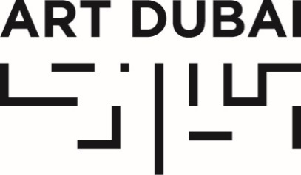
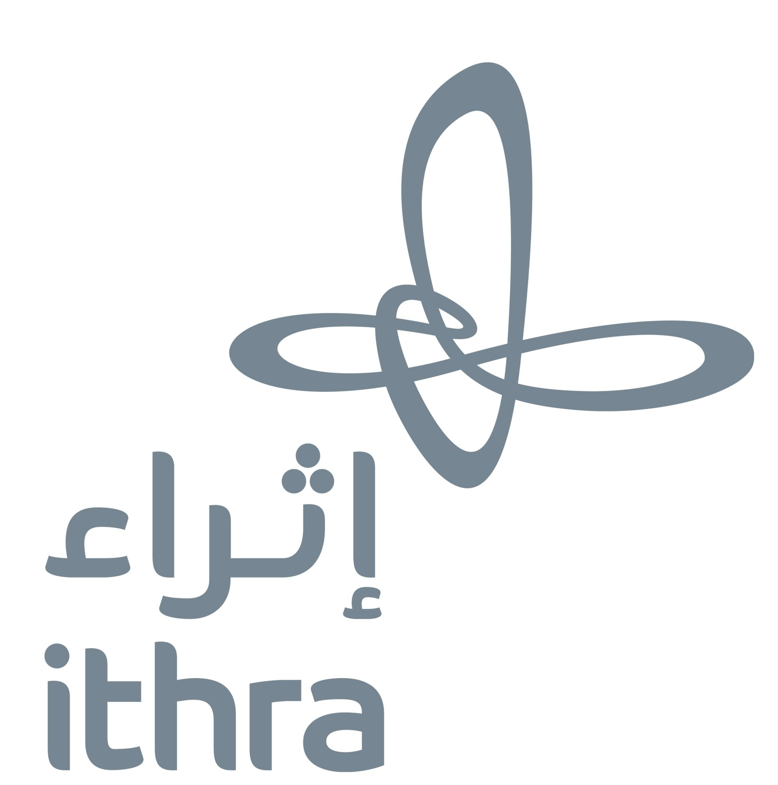
For immediate release

THIRD EDITION OF PRESTIGIOUS ITHRA ART PRIZE OPEN FOR SUBMISSIONS

- Ithra Art Prize is a joint initiative between Saudi Arabia’s Ithra and Art Dubai to support emerging artistic talent from Saudi Arabia
- Ithra Art Prize winner receives up to $100,000 to realize a major new artwork, which will debut at Art Dubai 2020 before joining Ithra’s permanent collection
- Deadline for submissions is October 3, 2019

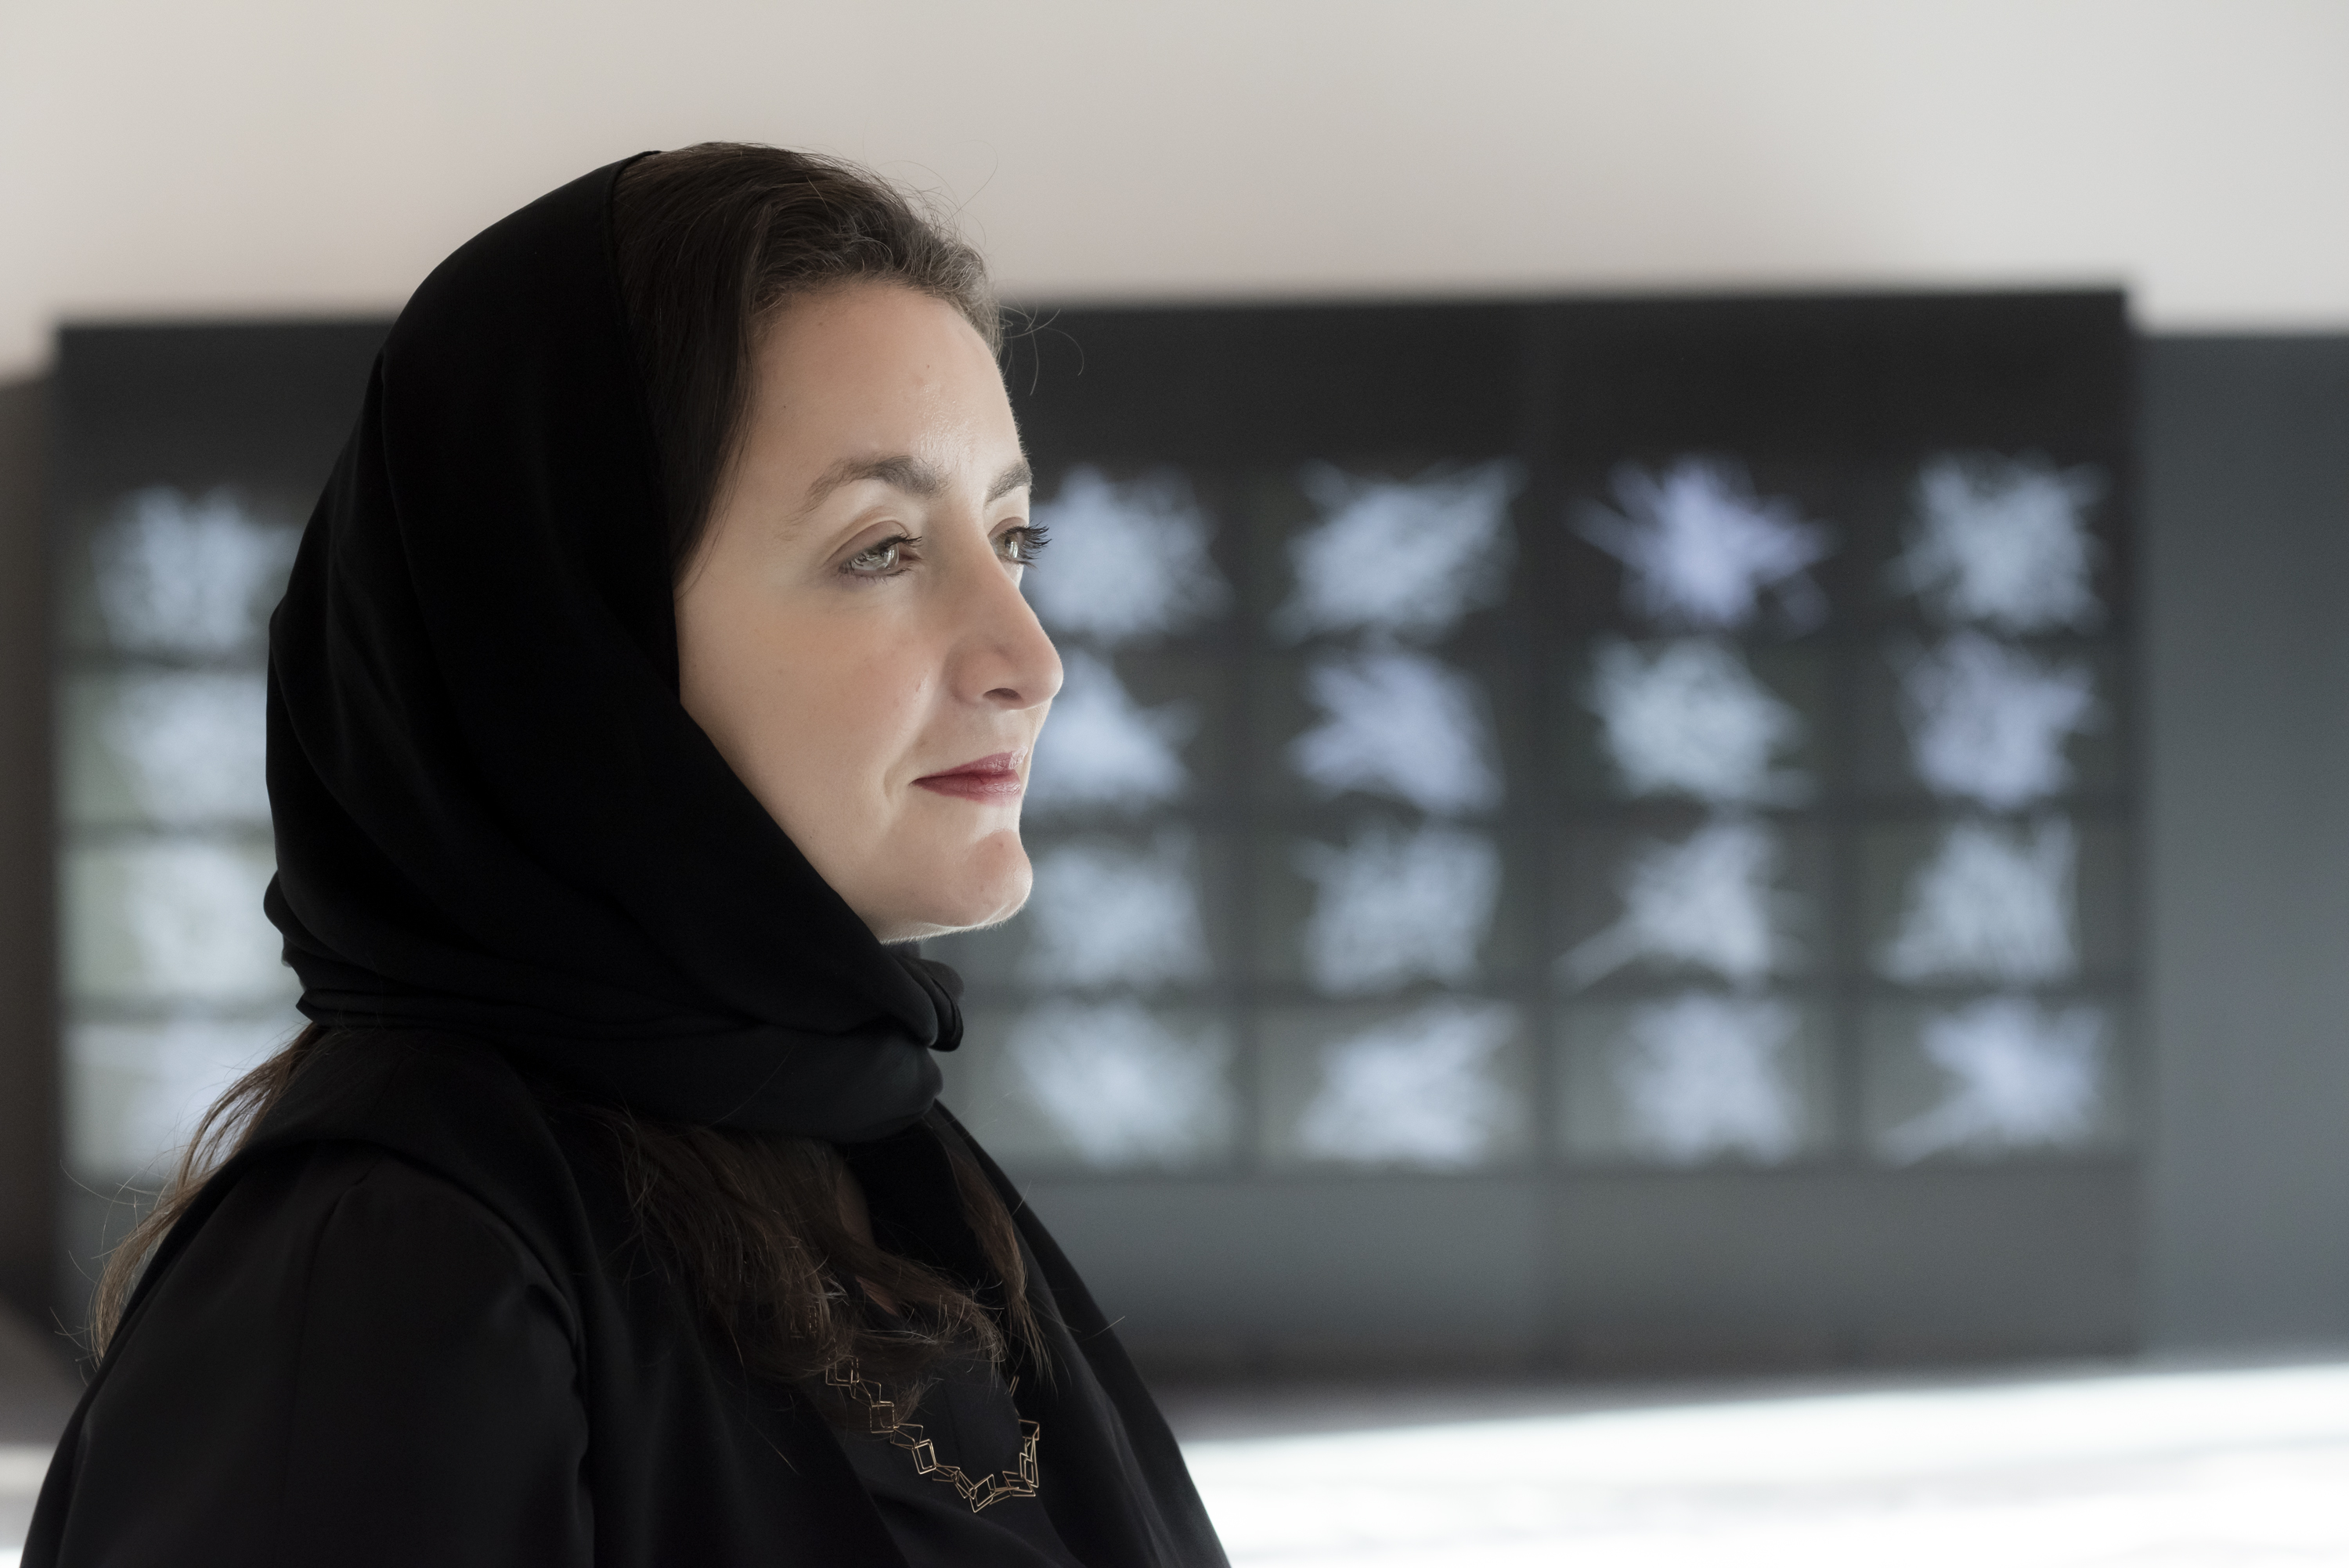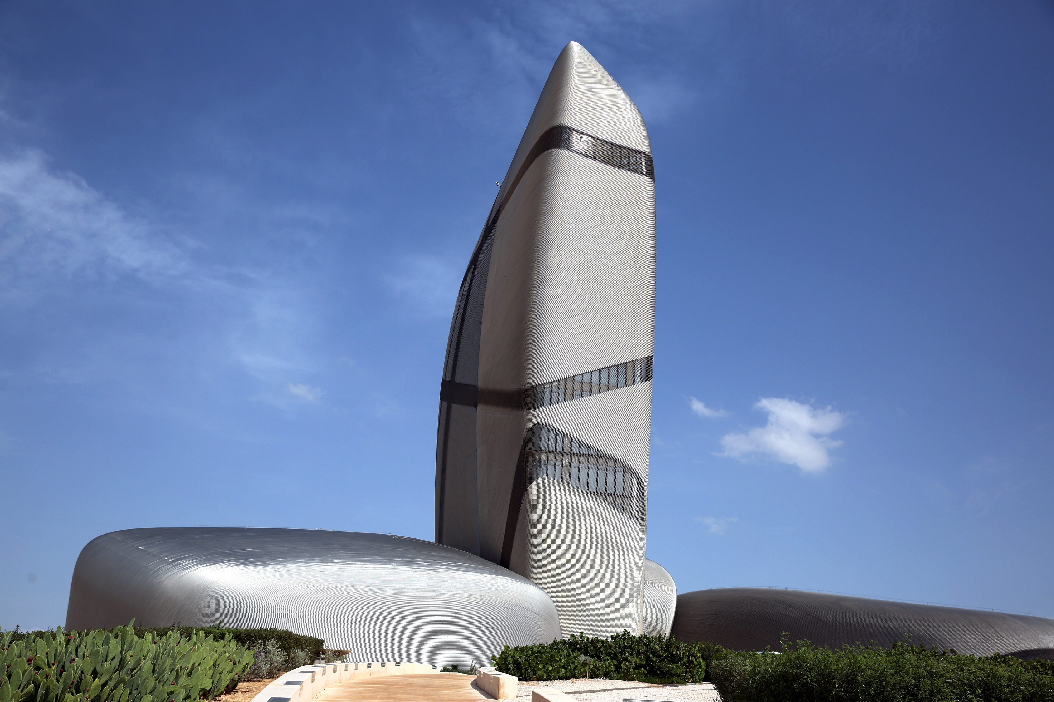
Ithra (The King Abdulaziz Center for World Culture), Dhahran, Saudi Arabia (credit to Ithra and Al Thani)

Ithra Art Prize 2019 winner, Daniah Alsaleh, in front of her winning commission Sawtam, at Art Dubai 2019 (credit to Art Dubai and Photo Solutions)

JULY 9, 2019, DHAHRAN, SAUDI ARABIA – Ithra (The King Abdulaziz Center for World Culture) and Art Dubai today announced the open call for the third Ithra Art Prize, an initiative first launched in 2017 to support and raise the profile of emerging Saudi and Saudi-based artistic talent on a truly international platform.

The region’s most signifiicant prize for Saudi and Saudi-based contemporary artists will accept artwork proposals for the 2020 edition of the Prize until October 3, 2019. Following a complete review and deliberation by a prestigious jury, the winning artist will be announced in late 2019 and will receive up to $100,000 to create a new commission. The selected art piece will debut at Art Dubai 2020 (March 25-28, 2020) before it joins previous winners as part of Ithra’s growing permanent art collection in Dhahran, Saudi Arabia. The Ithra Art Prize is adjudicated by a high-profile jury comprising individuals with strong connections to the Saudi, Arab and international art community. The jury will be announced next month.

Previous winners of the prize are Saudi conceptual artist Ayman Zedani and Daniah Alsaleh. Zedani’s commission, Meem, was exhibited at Art Dubai in 2018 while Daniah Alsaleh’s large-scale multimedia installation, Sawtam, was unveiled at Art Dubai this year and is currently part of ‘Artificial Intelligence and Intercultural Dialogue Art Exhibition’ at the Hermitage Museum in St. Petersburg, Russia.

Based in Dhahran, Saudi Arabia, Ithra is a creative and interactive public space for workshops, performances, events, exhibitions and experiences. It offers an enriching journey for everyone by championing diversity, celebrating creativity and encouraging collaboration with the objective of energizing Saudi Arabia’s knowledge economy, In 2018, it was listed by TIME Magazine as one of the world’s best 100 places to visit.

For more information on the application criteria, visit: https://www.ithra.com/en/pages/ithra-art-prize-2020
or https://www.artdubai.ae/ithra-art-prize-2020/

For images: https://www.dropbox.com/sh/93291kk0v9th97w/AAA-HWxq7e32U9fI2zgXr-fqa?dl=0

—END—

MEDIA CONTACTS
Mona Al Shehri
Media Relations, Ithra
mona.shehri@aramco.com
T: +966 504 967 179

Ciara Phillips
Acting Head of Communications and Outreach, Art Dubai
ciara@artduabi.ae
T +971 5 5686 9488

NOTES TO EDITORS

About the Ithra Art Prize
Launched in 2017 by the King Abdulaziz Center for World Culture (Ithra) in collaboration with Art Dubai, the Prize is awarded to emerging Saudi and Saudi-based talent in contemporary art as a means to fund, promote and offer artists from Saudi Arabia a global platform. Sharjah-based, Saudi Arabian artist Ayman Zedani was the winner of the first edition of the Prize in 2018, with London-based Saudi Arabian artist, Daniah Alsaleh 2019’s winner. The selection committee is made up of Saudi as well as international experts, including members of Ithra and Art Dubai. As part of a collaboration between Ithra and Art Dubai, the winning work is unveiled at Art Dubai each year, and subsequently joins Ithra’s prestigious permanent collection.

About the King Abdulaziz Center for World Culture
Inaugurated in 2016 by His Majesty King Salman, the King Abdulaziz Center for World Culture (Ithra) is a creative and interactive public space for workshops, performances, events, exhibitions and experiences. It offers an enriching journey for everyone by championing diversity, celebrating creativity and encouraging collaboration with the objective of energizing Saudi Arabia’s knowledge economy.

Ithra is Saudi Aramco’s most ambitious CSR initiative and the largest cultural contribution to the Kingdom. Through a compelling series of programs and initiatives, Ithra creates world-class experiences that bring together culture, innovation and knowledge and are designed to appeal to everyone. Through extraordinary offerings that are Saudi at heart and multicultural by nature, Ithra aims to transform industry and diversify Saudi Arabia’s economy to create a vibrant society. Ithra’s home-grown talent creates opportunities for discovery and cultural exchange by bringing together talent to achieve personal, professional and national ambitions.

Ithra's components include the Idea Lab, Library, Theater, Museum, Energy Exhibit, Art Gallery, Children’s Museum and Knowledge Tower.

A beacon for local, regional and international cultural events, the Center hosts several prominent events including as the 29th Arab League Summit, Tanween (Ithra’s annual creativity season), Russia’s Mariinksy Orchestra Theater, and the Saudi Film Festival, in addition to its year-round programming.

A spectacular structure comprising a collection of stones symbolizing unity, Ithra was designed by the Norwegian architectural firm Snohetta and stands as an iconic landmark rising 90 meters above the Dhahran skyline.

Follow Ithra on social media: Facebook (King Abdulaziz Center for World Culture), Twitter (@Ithra) and Instagram (@Ithra) #Ithra

About Art Dubai
Art Dubai is a leading international art fair as well as the world’s leading platform for Contemporary and Modern art from the MENASA region and returns to Madinat Jumeirah, Dubai for its 14th edition from March 25th to March 28th, 2020.

Mirroring Dubai’s position as a centre of trade and junction between different cultures, Art Dubai further acts as a place of discovery for art from centres that are usually omitted from the Western mainstream dialogue on art.

Art Dubai promotes regional art and artists by featuring a unique mix of programming and commissioned works, often in partnership with other regional institutions. Redefining the role an art fair should play, Art Dubai cultivates an ecosystem for art, education and thought leadership beyond the commercial aspects of the fair. Two examples of this are the fair's critically acclaimed Global Art Forum, an annual transdisciplinary summit taking place in Dubai and International locations, and Campus Art Dubai, a one-of-a-kind educational programme in the UAE.

The fair further acts as a grassroots-type institution for art and art production through initiatives such as Residents, a residency and gallery programme for international artists who are invited to the UAE for a 6-8 week artist residency to immerse themselves in the local scene.

Acting as a digital extension of Art Dubai’s offering, Art Dubai Portraits is a commissioned film series profiling artists that are connected to the fair through its programming or participating galleries. This serves as a one-of-a-kind resource for curators and researchers working with art and artists from the region.

The fair is sponsored by Julius Baer and Piaget, with Madinat Jumeirah as the home of the event. The Dubai Culture & Arts Authority (Dubai Culture) is a strategic partner of Art Dubai and supports the fair’s year-round education programme.

artdubai.ae

Twitter | Facebook | Instagram | #ArtDubai2020

