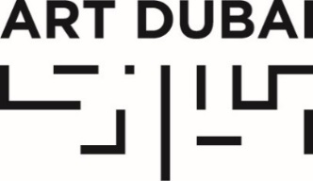

Press Release

ART DUBAI ANNOUNCES TALKS PROGRAMME FOR 2019 EDITION

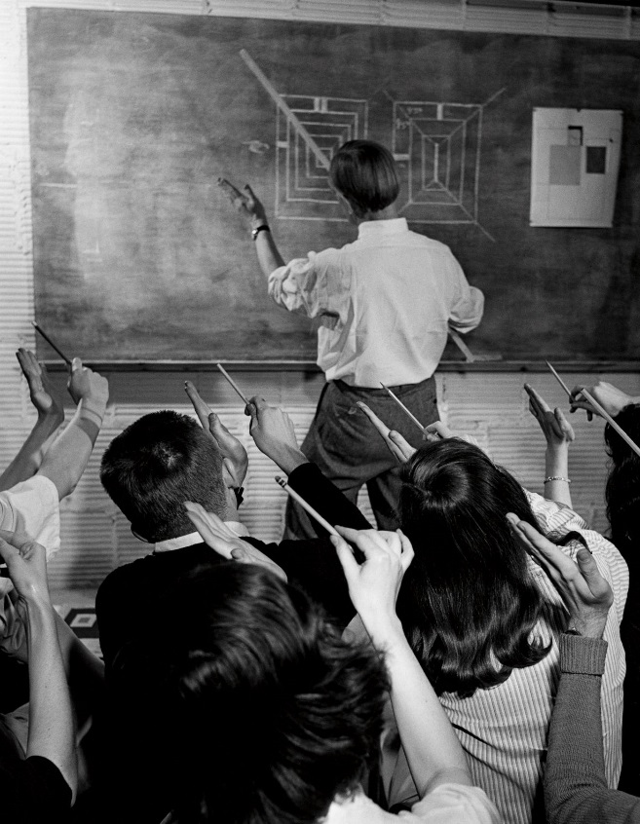
Artist Josef Albers with his class at Black Mountain College, shot for Life magazine
© Photo by Genevieve Naylor / Corbis via Getty Images

FEBRUARY 13, 2019, DUBAI, UNITED ARAB EMIRATES – Art Dubai, held under the patronage of His Highness Sheikh Mohammed bin Rashid Al Maktoum, Vice President and Prime Minister of the UAE and Ruler of Dubai, announced today the talks programme for its 13th edition, taking place Wednesday March 20 to Saturday March 23 at Madinat Jumeirah.

Talks and panel discussions have been an essential part of Art Dubai’s extensive cultural programming since 2007 and have united fair visitors with over 600 leading artists, curators, and galleries; art historians, art experts and opinion leaders; covering topics such as arts patronage and collecting; art history; and the social-political and cultural factors which influence contemporary art.

Highlights include the return of internationally-acclaimed annual transdisciplinary arts conference Global Art Forum; a full-day of knowledge exchange at Modern Symposium, which returns in a new format as a series of four one-hour ‘masterclasses’; and supporting talks for new gallery sections, Bawwaba.

GLOBAL ART FORUM: ‘SCHOOL IS A FACTORY?’ MARCH 20-21
Global Art Forum is an internationally-acclaimed annual transdisciplinary arts conference, which combines original thinking and contemporary themes in an intimate, live environment. This year’s two-day forum, the largest of its kind in the Middle East, North Africa and South Asia, is open to the public (including non-ticket holders) and free to attend.

Following on from last year’s theme of automation, Global Art Forum 2019 unites a diverse cast of global minds – from renowned curators and critics to educationalists and entrepreneurs – under the theme of ‘School is a Factory?’ to address some of the urgent challenges and opportunities facing education today.

Some of the pressing questions posed throughout the Forum’s lectures, presentations and conversations will be: “What should education prioritise in the coming decade?” “How should humans be taught in the age of accelerated mechanization?” “Is the notion of ‘learning for life’ just an opportunistic tagline?” “Will higher education escape the ghetto of elitism?” “Do past experiments in education have something to teach today?” and “Will we need humans to teach humans anymore, anyway?”

The 2019 iteration of Global Art Forum is organised by Commissioner Shumon Basar, with Editor and Writer Victoria Camblin, and Curator and Writer Fawz Kabra as Co-Directors. The Forum is supported by the UAE Ministry of Foreign Affairs and International Cooperation.

MODERN SYMPOSIUM: ‘CULTURAL HUBS OF MODERNISM’, MARCH 22
Art Dubai Modern Symposium accompanies Art Dubai Modern, the fair’s gallery section presenting museum-quality works by 20th Century masters from the MENASA region.

Under the title of ‘Cultural Hubs of Modernism’, this year’s Symposium attempts to map out the cultural shifts and trends instigated by modernity in four key cities in the Middle East and South Asia during the 20th century - Baghdad, Beirut, Dakar and Lahore – in a new 60-minute ‘masterclass’ format.

Renowed curators, scholars and patrons will each focus on a different city:
Dr Nada Shabout, professor and founding president of the Association for Modern and Contemporary Art from the Arab World, Iran and Turkey, presents ‘Performing Modernity: Baghdad of the Mid-twentieth Century’; Dr Iftikhar Dadi, professor and co-director of the Institute for Comparative Modernitiés, presents ‘Modern Art in Lahore’; Elvira Dyangani Ose, Director of The Showroom, London, will lecture on Dakar; and, Catherine David, deputy director of the National Museum of Modern Art at the Centre Georges Pompidou, delivers a masterclass session on Beirut.

BAWWABA: supporting talks, March 20
Curated by French Cameroonian Élise Atangana, Art Dubai’s new gallery section Bawwaba was created to shed light on artist interrogations of the notion of the Global South. With a spotlight on the Middle East, Africa, Central and South Asia, and Latin America, its first edition features 10 solo presentations which resonate deeply with narratives around colonisation histories and contemporary experiences.
Running alongside Bawwaba will be two supporting talks: ‘Arts Patronage in the Global South,’ a discussion exploring the diverse arts patronage models across the Global South, led by Ahmad Abu Ghazaleh, collector of Western, Middle Eastern and Arab art and President of the Mohammad and Mahera Abu Ghazaleh Foundation with participating collectors engaged in impactful arts patronage initiatives.
Mobilities & Imagined Utopias in the Global South’ is a panel looking at some of the artistic and non-profit institutional practices across the Global South that deal with notions of migration and nomadism, post-colonialism and imagined utopias. Participating panelists will be Ziba Ardalan, Founding director of Parasol Unit, London; Art Dubai Residents co-curators Fernanda Brenner and Munira Al Sayegh; Bawwaba curator Élise Atangana and artist Chourouk Hriech.
Art Dubai is sponsored by Julius Baer and Piaget, with Madinat Jumeirah as the home of the event. The Dubai Culture & Arts Authority (Dubai Culture) is a strategic partner of Art Dubai and supports the fair’s year-round education programme. BMW is the fair’s exclusive car partner.

—END—

MEDIA CONTACT

For further information including detailed talks schedules, speaker biographies and interview requests, please contact:
Ciara Phillips, Acting Head of Communications and Outreach
Art Dubai
ciara@artdubai.ae

NOTES TO EDITORS

About Art Dubai
Art Dubai is a leading international art fair as well as the world’s leading platform for Contemporary and Modern art from the MENASA region.

Mirroring Dubai’s position as a centre of trade and junction between different cultures, Art Dubai further acts as a place of discovery for art from centres that are usually omitted from the Western mainstream dialogue on art; in geographical terms referring to a region, which has recently become known as the 'Global South'.

Art Dubai promotes regional art and artists by featuring a unique mix of programming and commissioned works, often in partnership with other regional institutions. Redefining the role an art fair should play, Art Dubai cultivates an ecosystem for art, education and thought leadership beyond the commercial aspects of the fair. Two examples of this are the fair's critically acclaimed Global Art Forum, the largest arts conference in the Middle East and Asia, and Campus Art Dubai a one-of-a-kind educational programme in the UAE.

The fair further acts as a grassroots-type institution for art and art production through initiatives such as Residents, a programme-cum-gallery section for international artists, who are invited to the UAE for a 4-8 week residency to immerse themselves in the local scene.

Acting as a digital extension of Art Dubai’s offering, Art Dubai Portraits is a commissioned film series profiling artists that are connected to the fair through its programming or participating galleries. This serves as a one-of-a-kind resource for curators and researchers working with art and artists from the region.

The fair is sponsored by Julius Baer and Piaget, with Madinat Jumeirah as the home of the event. The Dubai Culture & Arts Authority (Dubai Culture) is a strategic partner of Art Dubai and supports the fair’s year-round education programme. BMW is the exclusive car partner of Art Dubai.

artdubai.ae
Twitter | Facebook | Instagram | #ArtDubai2019

