OPEN CALL TO ALL SAUDI ARTISTS TO TAKE PART IN A NEW CONTEMPORARY ART COMPETITION

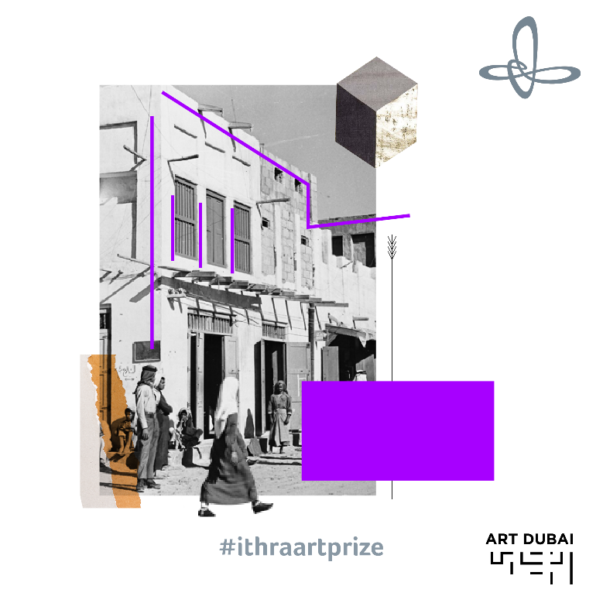

All Saudi artists are invited to take part in a new contemporary art competition, launched by the King Abdulaziz Center for World Culture (Ithra), in collaboration with Art Dubai. The winning artist will receive financial support to produce a commissioned installation, which will be exhibited at Art Dubai 2018 (March 21-24, 2018) and eventually become part of Ithra’s prestigious permanent collection. The deadline for applications is November 30 and the winner will be announced on January 16.

APPLY HERE

CRITERIA FOR APPLICATION:

- The artist will be from Saudi Arabia
- Artist group applications will be acceptable (limited to one installation per application)
- The commissioned piece will be a new work, exclusive to the Center and Art Dubai
- The installation must be a permanent piece, and the artist must submit a portfolio as well as a breakdown of the production costs
- The project must not exceed SAR 375,000, including shipping, insurance and project management, be in line with the size and weight restrictions (4m x 2.5m), and be culturally appropriate

CONTACTS:

COMPETITION ENQUIRIES MEDIA CONTACT
Benedetta Ghione Nicole Kanne
Art Dubai Art Dubai
benedetta@artdubai.ae nicole@artdubai.ae

About The King Abdulaziz Center for World Culture
The King Abdulaziz Center for World Culture’s building with its unique architecture rises as a shining beacon of knowledge in Dhahran’s skyline. The building, which is an initiative by Saudi Aramco, is significantly located near the Prosperity Well where oil was first discovered in commercial quantities in the Kingdom of Saudi Arabia. The purpose of this ambitious initiative is to accelerate the Kingdom’s transformation into a knowledge-based economy as envisioned by HM King Abdullah who laid the foundation stone for this iconic building.

The Center is the first incubator of knowledge of its kind in the Kingdom of Saudi Arabia. It brings together under its roof many programs that aim to create a positive and tangible impact in the fields of knowledge and culture by preparing the national talents for the knowledge-based and innovation-based creative industries.

The Center features a modern architectural design, state-of-the-art technologies, unique learning tools, and enriching programs. It is an important platform for explorers, intellectuals, innovators, and leaders. The Center – a diverse cultural space – has a 21st century library, an idea lab, an oasis for children, a four-gallery museum, art exhibits, an archives gallery, an energy exhibit, and a knowledge tower which stands at its heart to offer educational programs that cater to all age groups. The Center’s programs were all designed to inspire the community, enrich the culture, and support our community which is taking steady steps toward establishing a knowledge-based economy.

About Art Dubai
A leading international art fair, Art Dubai is the preeminent place to interact with art from the Middle East, North Africa and South Asia. For its 12th edition Art Dubai presents a unique line-up of 103 galleries from 47 countries, reaffirming the fair's position as a place of discovery with galleries from new markets rarely seen on the international stage exhibiting alongside leading galleries from established art centers. It will also showcase the largest edition of Art Dubai Modern – the world’s only platform that exhibits museum-quality Modern works from the MENASA region, alongside the annual Modern Symposium of talks on the lives and legacies of artists operating in these regions in the 20th century.

Art Dubai 2018 inaugurates a new gallery section – Residents – that welcomes spaces whose artists will complete a residency in the UAE with work created during this period exhibited at the fair.

Beyond the gallery halls, the fair once again hosts an extensive collateral programme including the 10th anniversary of The Abraaj Group Art Prize, the Global Art Forum that takes on the theme of automation, and a series of commissions including the artist collective GCC, which will welcome audiences to Good Morning GCC at the fair and an engaging after-hours programme including private visits to collections and to cultural institutions across the Emirates.

In addition to its March programming the fair aims to continue to grow the cultural fabric of the city and the region with year round engagement including the art school Campus Art Dubai, an internship programme aimed at supporting the next generation of art practitioners and professionals, and Art Dubai Portraits, a film series casting light on MENASA artists and their practices.

Art Dubai is held in partnership with The Abraaj Group. The fair is sponsored by Julius Baer, Meraas and Piaget. Madinat Jumeirah is home to the event. The Dubai Culture & Arts Authority (Dubai Culture) is a strategic partner of Art Dubai and supports the fair’s year-round education programme.

artdubai.ae

Twitter | Facebook | Instagram | #ArtDubai2018

