Press Release

For immediate release

THE KING ABDULAZIZ CENTER FOR WORLD CULTURE (ITHRA) ANNOUNCES WINNER OF FIRST EDITION OF ITHRA ART PRIZE

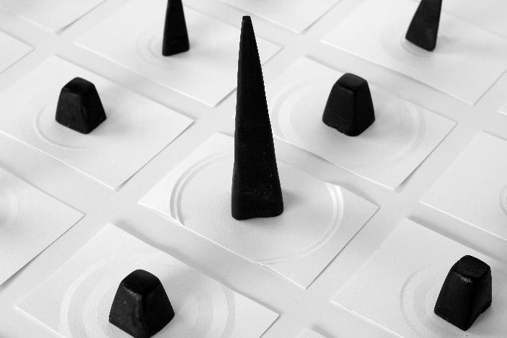
Ayman Zedani, Uthen, 2016. Courtesy the artist.

JANUARY 2018, DHAHRAN, SAUDI ARABIA – The King Abdulaziz Center for World Culture (Ithra) announced Sharjah-based, Saudi Arabian artist Ayman Zedani as the winner of the first edition of the Ithra Art Prize.

Launched in 2017, the Prize is awarded to emerging Saudi talent in contemporary art and was introduced by the King Abdulaziz Center for World Culture as a means to fund, promote and offer Saudi artists a global platform.

Ali Al-Mutairi, Director of the King Abdulaziz Center for World Culture (Ithra) commented: “The Center is a place where ideas and dreams take shape and we are excited about the prospect of highlighting Saudi talent such as Ayman. His proposal for the Ithra Art Prize is a great example of the potential we have in the region”.

Ayman Zedani said: “I am honoured to have been selected as the winner of the first edition of the Ithra Art Prize. This is a unique opportunity to present my work on a global scale and collaborate with an institution, whose contributions to the cultural development in Saudi Arabia I greatly admire”.

The first edition of the competition received over 80 proposals and the winner was chosen by a selection committee made up of Saudi as well as international experts, including members of the Center and Art Dubai.

As part of a collaboration between Ithra and Art Dubai, Zedani’s work will be unveiled at Art Dubai 2018 in March, and subsequently join Ithra’s prestigious permanent collection.

MEDIA CONTACT
Nicole Kanne
Art Dubai
nicole@artdubai.ae

NOTES TO EDITORS

About Ayman Zedani
Ayman Zedani (b. 1984 in Saudi Arabia) is interested in the creation of systems and the communicative possibilities that exist within a given set of rules. Grounded in rational logic as much as metaphysical interpretation, his work explores the process of perception, in which the inner self synthesizes a relationship with the outer world. Zedani’s recent projects include 4 (2017) organised by Maraya Art Center, Sharjah; 3 (2017) at Sharjah Art Museum and Tethered (2017) organised by TCA, Abu Dhabi. He will present a new project, Refusing to be Still (2018), at the fifth edition of 21’39 in Jeddah.

About The King Abdulaziz Center for World Culture
The King Abdulaziz Center for World Culture’s building with its unique architecture rises as a shining beacon of knowledge in Dhahran’s skyline. The building, which is an initiative by Saudi Aramco, is significantly located near the Prosperity Well where oil was first discovered in commercial quantities in the Kingdom of Saudi Arabia. The purpose of this ambitious initiative is to accelerate the Kingdom’s transformation into a knowledge-based economy as envisioned by HM King Abdullah who laid the foundation stone for this iconic building.

The Center is the first incubator of knowledge of its kind in the Kingdom of Saudi Arabia. It brings together under its roof many programs that aim to create a positive and tangible impact in the fields of knowledge and culture by preparing the national talents for the knowledge-based and innovation-based creative industries.

The Center features a modern architectural design, state-of-the-art technologies, unique learning tools, and enriching programs. It is an important platform for explorers, intellectuals, innovators, and leaders. The Center – a diverse cultural space – has a 21st century library, an idea lab, an oasis for children, a four-gallery museum, art exhibits, an archives gallery, an energy exhibit, and a knowledge tower which stands at its heart to offer educational programs that cater to all age groups. The Center’s programs were all designed to inspire the community, enrich the culture, and support our community which is taking steady steps toward establishing a knowledge-based economy.

