Press Release

HIROMI TANGO ANNOUNCED AS THE LEAD ARTIST FOR THE 6TH EDITION OF THE SHEIKHA MANAL LITTLE ARTISTS PROGRAM

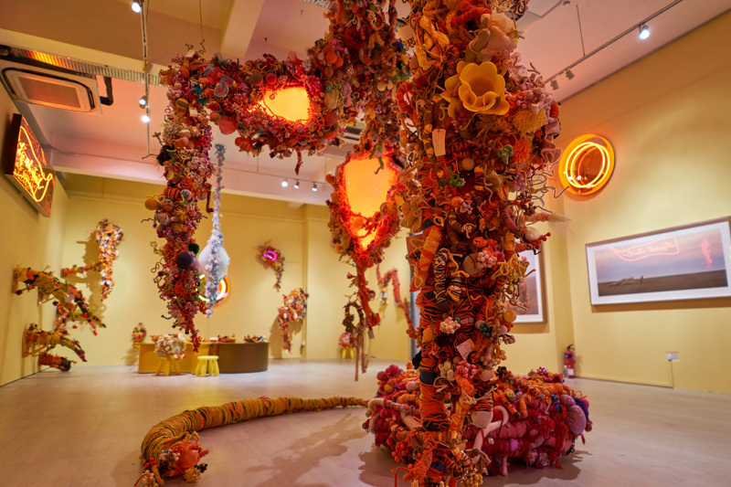
An installation by Hiromi Tango (2017), Photography Choo Gian Jie.

DUBAI, UNITED ARAB EMIRATES – Japanese-Australian Artist Hiromi Tango has been announced today as the lead artist for the sixth edition of the Sheikha Manal Little Artists Program, taking place at Art Dubai from March 21-24.

Held under the patronage of Her Highness Sheikha Manal bint Mohammed bin Rashid Al Maktoum, President of UAE Gender Balance Council, President of Dubai Women Establishment, and wife of His Highness Sheikh Mansour bin Zayed Al Nahyan, Deputy Prime Minister and Minister of Presidential Affairs UAE, the program is a partnership between The Cultural Office of Her Highness Sheikha Manal bint Mohammed bin Rashid Al Maktoum and Art Dubai, offering a unique educational opportunity for UAE-based children and teenagers, and encouraging them to excel in the arts. The program is part of Art Dubai’s longstanding commitment to education and the development of the UAE’s cultural landscape.

The artist’s project for this year’s edition is titled Healing Garden and will feature an interactive installation that invites children to participate in creating a nurturing environment based on local plants and flowers. With the iconic date palm as the focal point of the garden, Healing Garden explores the many ways that local plants and flowers can contribute to wellbeing. The workshops and immersive installation will provide hands-on opportunities for children to create and explore the space that is energized through the interplay of light, colors, textures and shapes.

Al Maha Al Bastaki, Director of The Cultural Office, commented: “In line with Her Highness Sheikha Manal bint Mohammed bin Rashid Al Maktoum’s unwavering commitment to expanding access to art education for children and teenagers in the UAE, the Sheikha Manal Little Artists Program plays a vital role in helping budding artists to tap into their creativity and unleash their artistic potential”

“We are delighted to welcome Hiromi Tango as this year’s lead artist, who has a track record of experience and research into this topic, and are looking forward to seeing her immersive installation come to life at this edition of Art Dubai,” Al Bastaki added.

Lead artist Hiromi Tango said: “I’m thrilled to have been chosen as the artist for the sixth edition of the prestigious Sheikha Manal Little Artists Program. My project Healing Garden will show the positive effect of art on children’s psyche and wellbeing. In addition to getting creative, the process of making the works will teach children to reflect on their own experiences with nature and learn how different gestures such as sorting or wrapping can transform thoughts, feelings and memories.”

—END—

MEDIA CONTACT
Nicole Kanne Reem Sadek
Art Dubai The Cultural Office
nicole@artdubai.ae reem.sadek@dwe.gov.ae

NOTES TO EDITORS

About The Artist

Hiromi Tango is a Japanese-Australian artist whose work spans sculpture, photography, installation and performance. Tango is dedicated to generating healing conversations through arts engagement. Addressing issues such as globalization and virtualization of communication, her practice is often collaborative, performative and site-specific. Although Tango’s works are highly personal and autobiographical, they can also be read as universal tropes of collective experience.
Her works have been exhibited at major Australian institutions, as well as international exhibitions in Singapore, Belgium, Switzerland, South Korea, Japan, and Hong Kong. Winner of the 2015 Gold Coast Art Prize, Tango was also a recipient of a Sidney Myer Creative Fellowship in 2017.

About the Sheikha Manal Little Artists Program
The Sheikha Manal Little Artists Program is held under the patronage of Her Highness Sheikha Manal bint Mohammed bin Rashid Al Maktoum, President of UAE Gender Balance Council, President of Dubai Women Establishment, and wife of His Highness Sheikh Mansour bin Zayed Al Nahyan, Deputy Prime Minister and Minister of Presidential Affairs UAE.
The Sheikha Manal Little Artists Program was launched by The Cultural Office of Sheikha Manal bint Mohammed bin Rashid Al Maktoum in partnership with Art Dubai in 2013. Featuring artist-led workshops, tours and other projects, the program provides access to skills and ideas for UAE-based children and teenagers aged 5-17 with the long-term aim of encouraging young people to get involved and excel in the arts. In its sixth year, the program continues to grow including the artist-led ‘Artists in Schools Initiative’ giving exclusive opportunity to selected schools to experience the workshops on campus.

About The Cultural Office
The Cultural Office of Her Highness Sheikha Manal bint Mohammed bin Rashid Al Maktoum was established in 2013 to serve as a leading platform to develop and activate substantial art movements as milestones within the region that will fortify the UAE's standing as a global hub for culture and creativity. Combining the best art practices and concepts from around the world, then tailoring it to respect and preserve our legacy and culture in the Arab world for International recognition, the projects undertaken by The Cultural Office are carefully selected to help raise the profile of the pool of talents existing in the region, based on the understanding that the cultivation and training of emerging talent is essential to ensure sustained excellence in the arts.
theculturaloffice.ae

About Art Dubai
A leading international art fair, Art Dubai is the preeminent place to interact with Contemporary art from the Middle East, North Africa and South Asia. For its 12th edition Art Dubai presents a unique line-up of 105 galleries from 48 countries, reaffirming the fair's position as a place of discovery with galleries from new markets rarely seen on the international stage exhibiting alongside leading galleries from established art centers. It will also showcase the largest edition of Art Dubai Modern – the world’s only platform that exhibits museum-quality Modern works from the MENASA region, alongside the annual Modern Symposium of talks on the lives and legacies of artists operating in these regions in the 20th century.

Art Dubai 2018 inaugurates a new gallery section – Residents – that welcomes spaces whose artists will complete a residency in the UAE with work created during this period exhibited at the fair.

Beyond the gallery halls, the fair once again hosts an extensive collateral program including the 10th anniversary of The Abraaj Group Art Prize, the Global Art Forum that takes on the theme of automation, and a series of commissions including the artist collective GCC, which will welcome audiences to Good Morning GCC at the fair and an engaging after-hours program, including private visits to collections and to cultural institutions across the United Arab Emirates.

In addition to its March programming, the fair aims to continue to grow the cultural fabric of the city and the region with year-round engagement including the art school Campus Art Dubai, an internship program aimed at supporting the next generation of art practitioners and professionals, and Art Dubai Portraits, a film series casting light on MENASA artists and their practices.

Art Dubai is held in partnership with The Abraaj Group. The fair is sponsored by Julius Baer and Piaget, with Madinat Jumeirah as the home of the event. The Dubai Culture & Arts Authority (Dubai Culture) is a strategic partner of Art Dubai and supports the fair’s year-round education program. MiSK Art Institute is the exclusive partner of Art Dubai Modern.

artdubai.ae

Twitter | Facebook | Instagram | #ArtDubai2018

