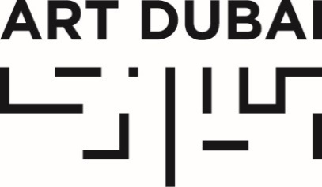

Press Release
Date of issue: February 7, 2018

GOOD MORNING GCC (.صباح الخير جي. سي. سي):
KHALEEJI ARTIST COLLECTIVE GCC TO RECREATE A LIVE TV SHOW
AT ART DUBAI FOR THE ROOM 2018

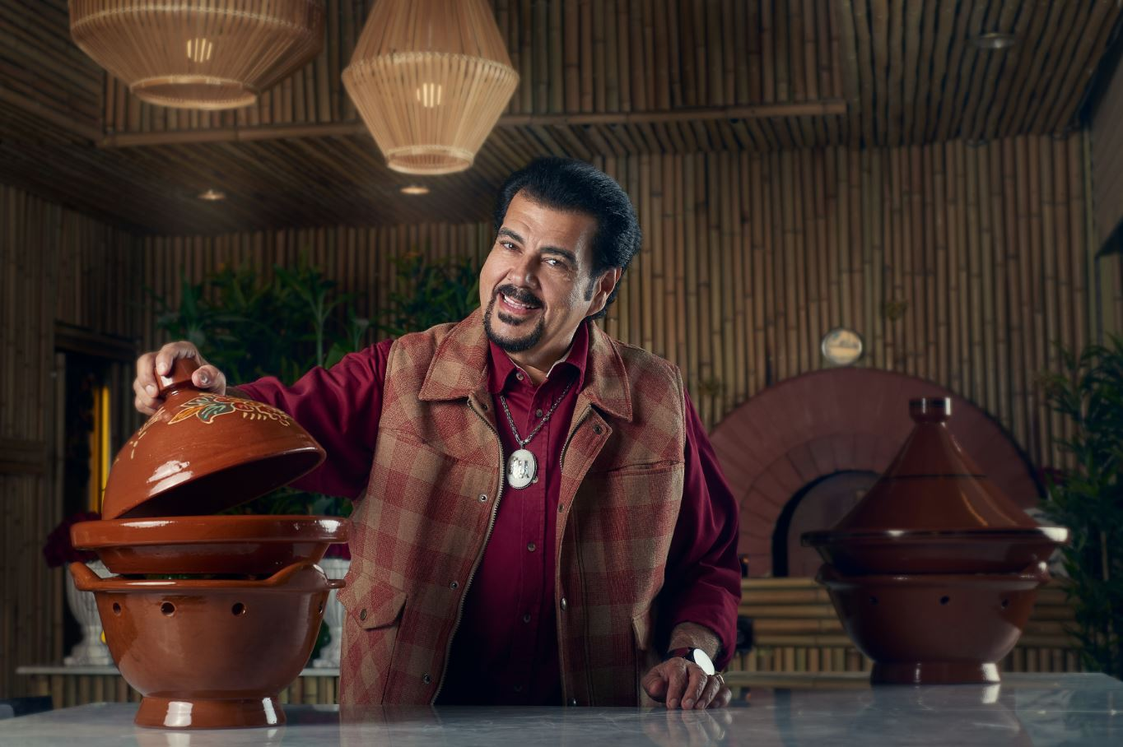
Suliman Al Qassar © Copyright Al Qassar Show

FEBRUARY 7, 2018, DUBAI, UNITED ARAB EMIRATES – The Khaleeji artist collective GCC, who met in the VIP lounge at Art Dubai in 2013, have been commissioned to produce the 2018 edition of The Room, Art Dubai’s interactive dining experience which is created by different artists each year at the fair.

Titled GOOD MORNING GCC (.صباح الخير جي. سي. سي), this year’s edition of The Room will recreate a live TV show on site, using the tropes of daytime talk shows commonly featured on TV stations across the Arab world as an anchor for the programming, which will include daily segments such as fashion, cooking and health.

A particular highlight will be the celebrity wedding singer and TV chef Suliman Al Qassar, an icon of food performance and much-loved TV personality in the region, who will launch the programme with a live cooking demonstration on the opening night of the fair.

The overall experience of the set will develop over the duration of the fair with daily performances, and visitors being able to interact with the props, furniture and scenography.

GCC commented: “We’re interested in how, this year, The Room has been moved from its exclusive space into a more public area. As a result we chose to approach figures like Suliman Al Qassar because of their relatability as regional icons and innovative personalities. With GOOD MORNING GCC, each guest participant has transformed the boundaries of their chosen profession beyond the staid.”

“GCC After Dark”

From Wednesday, March 21 – Friday, March 23, GCC’s TV studio set on Fort Island will serve as the background for a series of after-hours parties, featuring a line-up of internationally renowned DJ’s. The night events/segments will take place under the title GCC After Dark.

Further details on the day and night programming around The Room will be announced soon.

Tickets for Art Dubai are available via artdubai.ae

This year’s edition of The Room is supported by Ixina.

—END—

MEDIA CONTACT
Nicole Kanne
Art Dubai
nicole@artdubai.ae

NOTES TO EDITORS

About GCC
GCC, an acronym that does not necessarily stand for but alludes to the Gulf Cooperative Council (the intergovernmental political and economic partnership that connects six countries in the region), is an artist “delegation” or collective composed of eight members, all of which have strong ties to the Arabian Gulf. The group was formed in 2013 at Art Dubai and has since shown at Mitchell-Innes & Nash in New York; Kraupa-Tuskany Zeidler in Berlin; Project Native Informant in London; The New Museum, Whitney Museum of Art, and MoMA PS1 in New York; Musée d’Art Moderne in Paris; 9th Berlin Biennial; Sharjah Art Foundation, UAE; Fridericianum in Kassel; and the 78th Whitney Biennial.

Since its debut at Sultan Gallery, Kuwait, the group has continued to address the shifting systems of power in the Gulf region and abroad. GCC live between Kuwait, New York, Amsterdam, London, Berlin, and Chiang Mai.

Their works can be found in public and private collections including the Sharjah Art Foundation, The Barjeel Art Foundation, the Julia Stoschek Collection in Berlin and Düsseldorf, and Whitney Museum of American Art, New York.

About Suliman Al Qassar
Kuwaiti-born Suliman Al Qassar’s culinary career began during his childhood, when he learned the fundamentals of cooking particularly from his mother, grandmothers and aunts. Armed with a passion for travel, culture and cuisines, Al Qassar frequented the USA in the 1980s and these trips came to have a lasting impact on his profession. Largely inspired by the American Food Network, he developed a keen interest in cooking programmes and returned to his home country to establish his own culinary show, ‘Flavour and Seasoning with Al Qassar (Nak-ha w Buhar Ma’a Al Qassar)’ – one that merges his passions for music, performance and folklore and which has positioned him as a celebrated cultural and culinary figure in the Arab world.

About Art Dubai
A leading international art fair, Art Dubai is the preeminent place to interact with Contemporary art from the Middle East, North Africa and South Asia. For its 12th edition Art Dubai presents a unique line-up of 105 galleries from 48 countries, reaffirming the fair's position as a place of discovery with galleries from new markets rarely seen on the international stage exhibiting alongside leading galleries from established art centers. It will also showcase the largest edition of Art Dubai Modern – the world’s only platform that exhibits museum-quality Modern works from the MENASA region, alongside the annual Modern Symposium of talks on the lives and legacies of artists operating in these regions in the 20th century.

Art Dubai 2018 inaugurates a new gallery section – Residents – that welcomes spaces whose artists will complete a residency in the UAE with work created during this period exhibited at the fair.

Beyond the gallery halls, the fair once again hosts an extensive collateral programme including the 10th anniversary of The Abraaj Group Art Prize, the Global Art Forum that takes on the theme of automation, and a series of commissions including the artist collective GCC, which will welcome audiences to Good Morning GCC at the fair and an engaging after-hours programme, including private visits to collections and to cultural institutions across the United Arab Emirates.

In addition to its March programming, the fair aims to continue to grow the cultural fabric of the city and the region with year round engagement including the art school Campus Art Dubai, an internship programme aimed at supporting the next generation of art practitioners and professionals, and Art Dubai Portraits, a film series casting light on MENASA artists and their practices.

Art Dubai is held in partnership with The Abraaj Group. The fair is sponsored by Julius Baer and Piaget, with Madinat Jumeirah as the home of the event. The Dubai Culture & Arts Authority (Dubai Culture) is a strategic partner of Art Dubai and supports the fair’s year-round education programme. MiSK Art Institute is the exclusive partner of Art Dubai Modern.

artdubai.ae

Twitter | Facebook | Instagram | #ArtDubai2018

