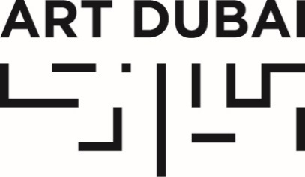

Press Release
Date of Issue: July 26, 2017

ART DUBAI ANNOUNCES CURATORIAL PARTNERSHIP WITH ART JAMEEL FOR CAMPUS ART DUBAI 6.0

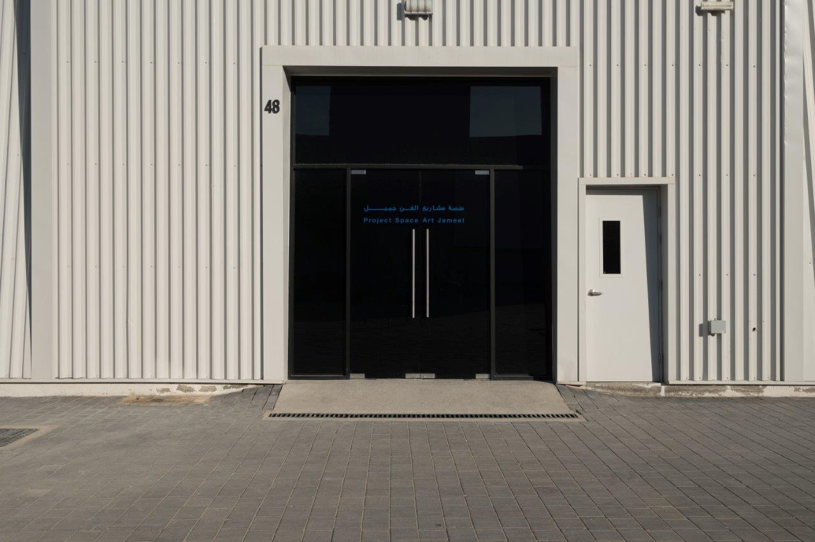
Project Space Art Jameel

July 26, 2017, Dubai, United Arab Emirates – Art Dubai announced today a curatorial partnership with Art Jameel for the upcoming edition of its Campus Art Dubai (CAD) programme, a highly competitive educational platform for artists, curators, writers and cultural producers based in the UAE. Complementing an in-depth syllabus of lectures and seminars, CAD features workshops, talks and courses by renowned local and visiting tutors focussing on topics of critical thinking and contemporary practices.

To mark this curatorial collaboration, Project Space Art Jameel is converting its gallery into a six-week experimental summer studio for current CAD members and alumni. Running from July 30 till September 6, 2017, the communal studio will provide participants with a semi-public environment to practice, create, research and exchange ideas. This will culminate in an open studio taking place on August 26 at 5pm at Project Space Art Jameel in Alserkal Avenue, where artists will showcase original, new work. The studio will remain open until the end of the programme on September 6 and offer ongoing tours with the artists present.

A public strand of the studio programme will include the following elements (registration via Art Jameel website is required):
- Dubai-based artist and CAD tutor Lantian Xie will lead a four-part Reading Club. Sessions will focus on themes of “nostalgia and memory as architectures of violence” and will take the form of seminars, with emphasis on conversation and discussions
- The studio participants will also extend a special invitation for creatives to join in on the CAD alumni tradition of regular dinners about town with the aim of discussing notions of formality versus familiarity and potential collaborations when joining a new cohort
- UAE-based artist Nadine Ghandour will be holding two Drawing-from-Film workshops with one dedicated specifically to teenagers. The films will be a selection of video clips from satellite and personal footage exploring varying viewpoints on loop

This collaboration is part of Art Jameel’s diverse programming dedicated to arts education and the support of UAE-based artists and creatives. The partnership will also offer CAD participants special access to Art Jameel research facilities and library upon Jameel Art Centre’s opening in 2018.

Looking forward, CAD 6.0 will be entitled Theme, Format, Mood, Setting. The programme will discuss different topics relevant to everyday life in the Gulf. Drawing from a variety of media across literature, cinema, and sound, CAD 6.0 will investigate the Gulf as Rom-Com, Sci-Fi, Historical Fiction, Action, Surrealist, Noir, Travelogue, Documentary, and Western. UAE-based artists, writers, curators, designers, architects and cultural producers are invited to apply for the sixth edition for Campus Art Dubai via: http://www.artdubai.ae/campus-art-dubai-6-0/ . The deadline for applications is September 7, 2017.

—END—

Media Contact
Amina Samy
Communications, Art Dubai
amina@artdubai.ae
+971 4 563 1417

NOTES TO EDITORS

About Campus Art Dubai
Campus Art Dubai (CAD) is the first and only programme of its kind in the UAE; the intensive six-month course gives UAE-based artists, writers, curators and cultural producers the opportunity to develop their practices under the mentorship of world renowned curators. Meetings occur over weekends and feature courses, talks, workshops, taught and led by a local and international cast of academics, critics, curators and artists. The course provides a space for critical thinking and the exchange of ideas and skills, with participants encouraged to collaborate, debate and challenge. Campus Art Dubai is a highly competitive membership-level programme open to serious career-oriented artists, writers and curators. CAD 6.0 is led by Uzma Z. Rizvi, Murtaza Vali and Lantian Xie.

Campus Art Dubai is part of Art Dubai’s educational programming and is held in partnership with Dubai Culture and Arts Authority, and Dubai Design District (d3) with Art Jameel as the 2017-18 curatorial partner.
Campus Art Dubai

Twitter | Facebook | Instagram | #CampusArtDubai

About Art Dubai
The preeminent platform to interact with art from the Middle East and North Africa, Art Dubai is a leading international art fair. Mirroring the cosmopolitanism and diversity of its hometown Dubai, it is the most globally diverse art fair. Through the fair and its year-round activities, Art Dubai also plays a leading role for the cultural development of Dubai, thus redefining the role an art fair can play; its year-long thought leadership, education and programming activities such as the Global Art Forum, Campus Art Dubai and Art Dubai Projects have been instrumental in building the framework for supporting artistic talent in the city and beyond.

Art Dubai is held in partnership with The Abraaj Group. The fair is sponsored by Julius Baer, Meraas and Piaget. Madinat Jumeirah is home to the event. The Dubai Culture & Arts Authority (Dubai Culture) is a strategic partner of Art Dubai and supports the fair’s year-round education programme.

The twelfth edition of Art Dubai takes place March 21-24, 2018.

Art Dubai

Twitter | Facebook | Instagram | #ArtDubai2018

About Art Jameel
Art Jameel is a non-profit organisation that supports artists and creative communities. Current initiatives include running heritage institutes and restoration programmes, plus a broad range of arts and educational initiatives for all ages. The organisation's programmes foster the role of the arts in building open, connected communities; at a time of flux and dramatic societal shifts, this role is understood as more crucial than ever.

Art Jameel’s model is collaborative: major institutional partners include the Victoria & Albert Museum, the Prince’s School of Traditional Arts and the Metropolitan Museum of Art; locally, the organisation works with individuals and organisations to develop innovative programming that embraces both ancient and new technologies, and encourages entrepreneurship and the development of cultural networks.

Art Jameel is positioned alongside Community Jameel, and complements its sister organisation’s work in promoting positive social change, job creation and poverty alleviation across the Middle East, North Africa and Turkey.

Art Jameel

Twitter | Facebook | Instagram | #artjameeldxb

