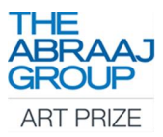

Press Release

THE ABRAAJ GROUP ANNOUNCES WINNING CURATOR FOR THE 10TH EDITION OF THE ABRAAJ GROUP ART PRIZE

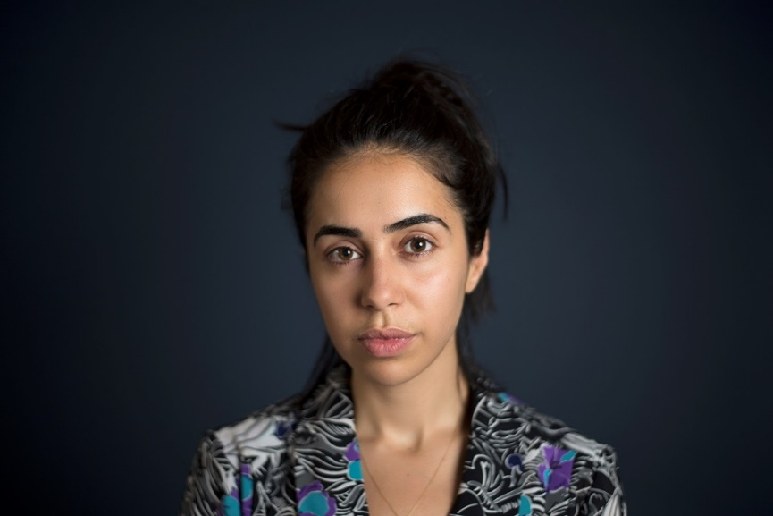
Myriam Ben Salah, curator of the 10th edition of the Abraaj Group Art Prize.
Photo courtesy Deborah Farnault.

Dubai, UAE, June 1, 2017 – The Abraaj Group today announced Tunisian-born and Paris-based writer and curator Myriam Ben Salah as the new curator for the upcoming edition of The Abraaj Group Art Prize. Ben Salah has been responsible for coordinating special projects and public programmes at the Palais de Tokyo in Paris and is Editor-in-Chief of the international edition of Kaleidoscope Magazine.
“I am very excited to have been chosen as the Guest Curator of the 10th edition of the Abraaj Group Art Prize. My curatorial practice covers different scopes and in recent years, I have felt an urgency to work towards shifting the narratives around the MENASA region and its artistic practices. I admire how Abraaj has been consistently supporting artists by offering them a platform for production and the opportunity to realise ambitious projects. Having the resources to produce is the cornerstone to a relevant art scene,” said Ben Salah.
Chair of the Abraaj Group Art Prize Dana Farouki commented: “Over the last ten years, The Abraaj Group Art Prize has become an exceptional platform for artists and curators working in the region. We had a great number of excellent applications from curators of over 41 nationalities this year, which made it difficult to choose. Myriam’s application really stood out and we’re delighted to have her on board for the 10th edition of the Prize.”
Each year, The Abraaj Group awards $100,000 to a winning artist to develop a new commission, and $10,000 each to three shortlisted artists to support the development of their artistic practice. The work of the winning artist is unveiled at each edition of Art Dubai, and complemented by an exhibition of works by the three shortlisted artists. Recognised as a unique opportunity for artists and curators in the region, 2018 will mark the 10th anniversary of the Prize.

This year, the Abraaj Group Art Prize Chair, Dana Farouki, and two permanent jury members Fayeeza Naqvi, Founding Trustee, Aman Foundation and Frederic Sicre, Managing Director, The Abraaj Group, welcome four new jury members:

- Zeina Arida, Director, Nicolas Ibrahim Sursock Museum, Beirut
- Myrna Ayad, Director, Art Dubai
- Stuart Comer, Chief Curator of Media and Performance Art, MoMA, New York
- Rashid Rana, Artist and Curator of the Lahore Biennale
- Omar Berrada, Guest Curator of the 2016 Abraaj Group Art Prize, who sits on the jury for one year

Applications for artists close on June 2, 2017.

For further information and to apply please visit:
The Abraaj Group
The Abraaj Group Art Prize
Art Dubai

Press Enquiries:
Nicole Kanne
Art Dubai
nicole@artdubai.ae
+971 (0)4 563 1417

Twitter
Facebook

--- END ---

NOTES TO EDITORS

About Myriam Ben Salah
Myriam Ben Salah (b. 1985, Algiers) is a curator and writer based in Paris, where she has been coordinating special projects and public programmes at the Palais de Tokyo since 2009, focusing particularly on performance art, video and publishing initiatives. She is the Editor-in-Chief of KALEIDOSCOPE magazine’s international edition and co-edits F.A.Q., a periodical image-only magazine with artist Maurizio Cattelan, as well as Feb (Mag), the publication of the Underground Museum in Los Angeles. Her writings have appeared in numerous international art publications. Her latest curatorial projects include We Dance, We Smoke, We Kiss (Fahrenheit, Los Angeles, 2016) Cool Memories (Occidental Temporary, Paris, 2016), Like the Desert Miss the Real (Galerie Steinek as part of Curated-by, Vienna, 2015), Dirty Linen (DESTE Foundation at the Benaki Museum, Athens, 2015), Shit and Die (Palazzo Cavour as part of Artissima collateral program, Turin, 2014).

About Art Dubai
The preeminent platform to interact with art from the Middle East and North Africa, Art Dubai is a leading international art fair. Mirroring the cosmopolitanism and diversity of its hometown Dubai, it is the most globally diverse art fair. Through the fair and its year-round activities, Art Dubai also plays a leading role for the cultural development of Dubai, thus redefining the role an art fair can play; its year-long thought leadership, education and commissioning programming activities such as the Global Art Forum, Campus Art Dubai and Art Dubai Projects have been instrumental in building the framework for supporting artistic talent in the city and beyond.

Art Dubai is held in partnership with The Abraaj Group. The fair is sponsored by Julius Baer, Meraas and Piaget. Madinat Jumeirah is home to the event. The Dubai Culture & Arts Authority (Dubai Culture) is a strategic partner of Art Dubai and supports the fair’s year-round education programme.

The twelfth edition of Art Dubai takes place March 21-24, 2018.

Art Dubai

Twitter | Facebook | Instagram | #ArtDubai18

About The Abraaj Group Art Prize
The Abraaj Group is a leading private equity investor, purpose-built for operating in the growth markets of Africa, Asia, Latin America, the Middle East, and Turkey. Through its Stakeholder and Strategic Partnerships programs, the Group supports art and innovation, entrepreneurship and the next generation, aiming to have a deep rooted and sustainable impact across growth markets.

The Abraaj Group Art Prize was founded in 2008 and is now in its ninth edition. The aim of the prize is to empower potential and give often under-represented contemporary artists the resources to further develop their talent. Following the application and jury process, four artists are shortlisted for the prize and one (of the four) artists awarded the $100,000 commission. The three shortlisted artists receive a cash prize and are represented in a group exhibition at Art Dubai (March 15-18, 2017) through previous works, which are selected by the Guest Curator in liaison with the artist. The prize reflects Abraaj’s own investment philosophy, which is to take viable businesses with great potential, and create regional and global champions. To date, the 2009, 2010, 2011, 2012, 2013, 2014, 2015 and 2016 works were presented at Art Dubai and then gone on loan to exhibitions at Istanbul Modern, Istanbul, Singapore Art Museum, Singapore, Sharjah Biennale 11, Sharjah, the 54th Venice Biennale, Venice, the 18th Biennale of Sydney, Sydney, V&A, London, Boghossian Foundation, Brussels, Palais de Tokyo, Paris, Kochi-Muziris Biennale, Kochi, Hangzhou Triennial of Fiber Art, Zhejiang, Kunsthalle Wien, Vienna, Tensta Konstall, Stockholm, Glasgow Sculpture Studios, Glasgow, 10th Gwangju Biennale, Gwangju, New Museum, New York.

