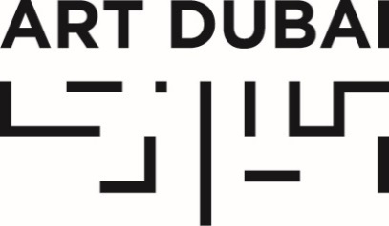

GALLERY APPLICATIONS OPEN FOR ART DUBAI 2018

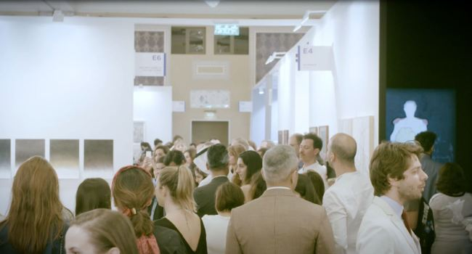
Art Dubai: Scenes from a City [film still]

Applications for galleries for the 12th edition of Art Dubai, taking place March 21-24, 2018 at Madinat Jumeirah, are now open.

Art Dubai Contemporary welcomes applications from commercial galleries operating in the primary market that have been established for at least two years. It includes two gallery programmes, exhibited alongside each other: Collective, the main section featuring exhibition booths with three or more artists as well as Solo, dedicated to one or two-artist presentations.

All applications are reviewed by Art Dubai’s Selection Committee, comprised of gallerists Isabelle van den Eynde (Gallery Isabelle van den Eynde, Dubai), Ursula Krinzinger (Galerie Krinzinger, Vienna), Glenn Scott-Wright (Victoria Miro Gallery, London/Venice) and Andrée Sfeir-Semler (Galerie Sfeir-Semler, Hamburg/Beirut). Sam Bardaouil and Till Fellrath are the Guest Curators that support the Committee in the selection process.

Art Dubai Modern is devoted to Modern art from the Middle East, Africa and South Asia, presented by galleries from these regions and beyond. Each exhibitor presents a solo or multi-artist show, featuring works by Modern masters from the 20th century (up to the year 2000).

Apply here

The deadline for applications is September 15, 2017.

For any further enquiries please contact:
Shahane Hakobyan
Exhibitor Relations Coordinator, Art Dubai
shahane@artdubai.ae
+971 (0)4 563 1404

artdubai.ae

Facebook | Instagram | Twitter | #ArtDubai18

