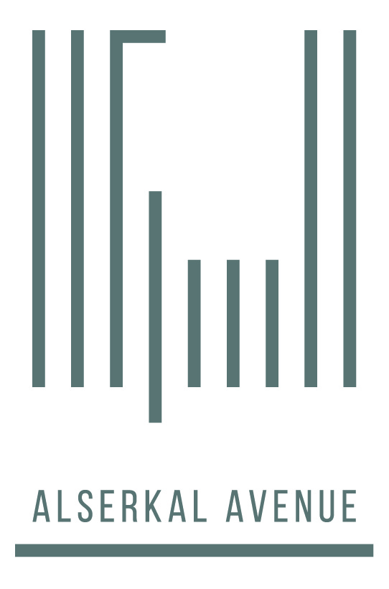
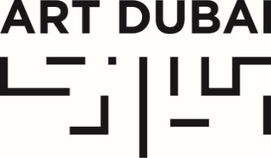

For immediate release
February 24, 2016

RCA SECRET DUBAI RETURNS FOR ART WEEK 2016

Visitors will have the opportunity to purchase original artwork by local and internationally-acclaimed artists at Alserkal Avenue and Art Dubai

FEBRUARY 24, 2016 DUBAI, UAE – Back by popular demand, RCA Secret Dubai – Dubai’s edition of the Royal College of Art’s anonymous art exhibition and sale – returns to Art Dubai this year and is held in partnership with Alserkal Avenue. For the first time, the sale will take place across two key locations during Art Week.

The 2016 RCA Secret Dubai will feature 1,000 original post-card size artworks displayed for sale at Alserkal Avenue (March 14-19) and Art Dubai (March 17-19). The anonymous collection is created and donated by regionally and internationally acclaimed artists and designers, plus alumni from the Royal College of Art in London. All proceeds support the university’s scholarship fund to support art students at a formative time in their careers.
Previous contributors to RCA Secret Dubai include world-renowned fashion designers Paul Smith, Zandra Rhodes, Christopher Bailey and Orla Kiely; architect Zaha Hadid; artists Hajra Waheed, Adel Abidin, Najat Makki and eL Seed; and the iconic photographer David Bailey.
Art enthusiasts must register their interest, either online or in person, in this unique opportunity to purchase original works of art for just 500 dirhams. Registered buyers select and purchase a postcard from the RCA Secret wall at Art Dubai and Alserkal Avenue, without knowing who the artists is. The talent behind the postcard artwork is only revealed after the sale in London is closed, after April 16. Collection of the purchased pieces will take place only on March 19. If buyers are unable to collect, the piece can be couriered (courier rates apply). Buyers will be able to purchase up to four cards each.

RCA Secret Dubai Sale Dates & Timings
At Art Dubai  March 17, 4pm-9pm  March 18, 2pm-9pm  March 19, 12pm-6pm | At Alserkal Avenue  March 14, 11am-5pm (Exhibition only), 5pm-9pm (Sale)  March 15-19, 10am-7pm
To register as an RCA Secret Dubai Buyer, click here.
For more information on RCA Secret Dubai, click here.

Media Enquires:
Tryphena Greenwood / Dana Sleiman
Asda’a Burson-Marsteller
artdubai@bm.com
+971 4 450 7600
NOTES TO EDITORS
ABOUT ART DUBAI
Art Dubai is held under the Patronage of HH Sheikh Mohammed bin Rashid Al Maktoum, Vice President and Prime Minister of the UAE and Ruler of Dubai.

Art Dubai is held in partnership with The Abraaj Group and is sponsored by Julius Baer and Piaget. Madinat Jumeirah is home to the event. The Dubai Culture and Arts Authority is a strategic partner of Art Dubai and, along with Dubai Design District (d3), supports the fair’s year-round education programme.

Art Dubai 2016 includes 94 galleries, presented across three programmes – Contemporary, Modern and Marker. Art Dubai’s extensive not-for-profit programme includes Art Dubai Projects; an exhibition of works by winners of the annual Abraaj Group Art Prize; a range of educational programmes including the Sheikha Manal Little Artists Program and the community school Campus Art Dubai; and the critically-acclaimed Global Art Forum.

The tenth edition of Art Dubai takes place March 16-19, 2016. artdubai.ae

Twitter | Facebook | Instagram | #AD16

ABOUT ALSERKAL AVENUE

Alserkal Avenue is the region’s foremost arts and culture neighbourhood located in Al Quoz, Dubai. Since it was established in 2007, Alserkal Avenue has grown to become an essential platform for the development of homegrown artistic and cultural initiatives, supporting a vibrant community of contemporary art galleries and alternative art spaces, together with design, media and industrial studios. In 2015 Alserkal Avenue began introducing its own homegrown programme as an arts organization, dedicated to encouraging new ideas, open dialogue and a more diverse and rich eco-system for art in the region. In 2016 Alserkal Avenue will see the launch its project space as well as art, design and creative concepts. alserkalavenue.ae

ABOUT THE ROYAL COLLEGE OF ART
The Royal College of Art is the world’s leading university of art and design, placing at Number One in the 2015 QS World University Rankings. Specialising in teaching and research, the RCA offers the degrees of MA, MPhil, MRes and PhD across the disciplines of applied art, fine art, design, communications and humanities. There are over 1,500 Master’s and doctoral students and more than 1,000 professionals interacting with them – including scholars, art and design practitioners, along with specialists, advisers and distinguished visitors.

